

Social Skills – Parent Note
Your child just completed a social skills lesson. The topic was:
My Brain – Your Brain: Understanding Perspective-Taking. Your knowledge of this lesson may help you to help your child generalize the skills to other environments.
What he/she learned:
- Introduction
Title and purpose: understanding perspective-taking.
Definition of perspective-taking.
- Why Perspectives Differ
People can interpret the same situation differently.
Others do not automatically know what we know.
Respecting different thoughts and feelings supports friendships.
Different perspectives are not necessarily right or wrong.
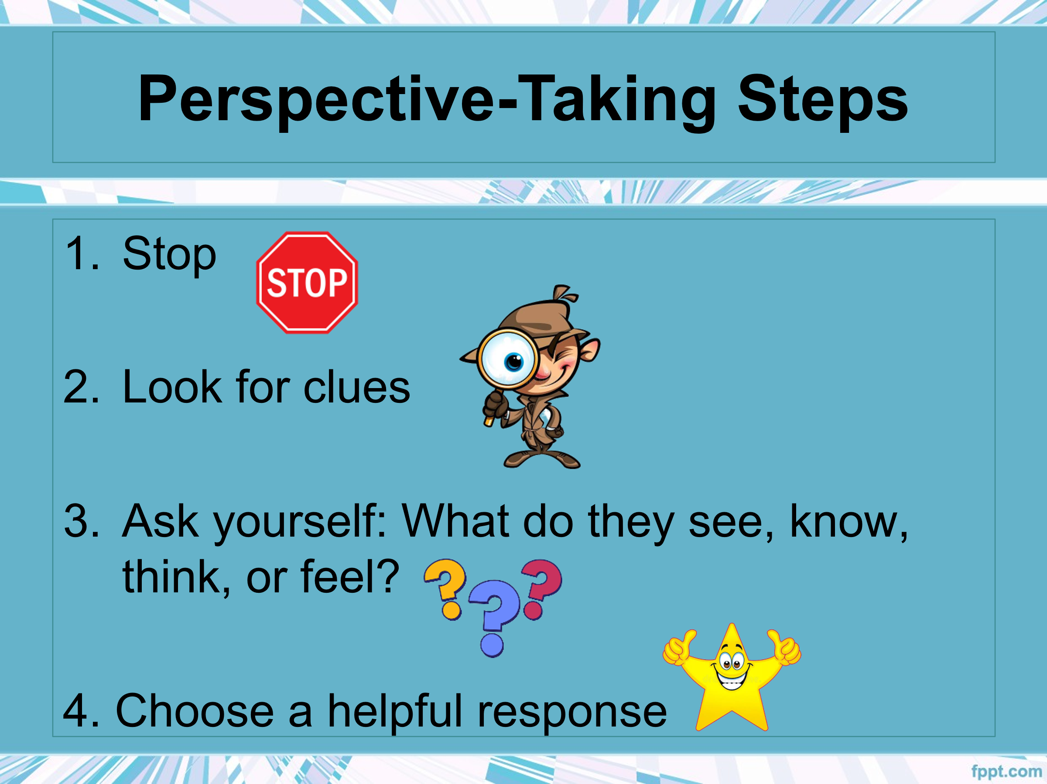
- Finding Perspective Clues
Use facial expressions, body language, words, and context.
Practice interpreting each type of clue.
Consider what the person has seen, heard, or been told.
- Guided Practice
Apply perspective-taking to the hidden-pencil scenario.
Explore how one situation can produce different feelings.
- Choosing Helpful Words
Decide whether to think or say something using truth, kindness, and helpfulness.
Infer thoughts in challenging social situations.
- Apply and Reflect: So…What do YOU think?
Follow four steps: stop, observe, consider the other perspective, and respond helpfully.
We finished with a real-life response scenario.
Your child received a Lesson Summary magnet:

If you have a moment, email _____________________________ with any information that might help your child for the next lesson on ________________________. THANK YOU!!

