What’s Happening Today?

Let’s Talk About Perspective-Taking

- Perspective-Taking means thinking about what another person may see, know, think, or feel

- People can have thoughts or feelings that may be different from ours. Understanding their perspective can help us make and keep friends!

- There are 4 clues we can use to help us understand another person’s perspective: look at their face, body language, listen to their words, and take in the situation.

- Should we just think it or say it?

- 4 Perspective-Taking Steps

- Stop
- Look for clues
- Ask yourself: What do they see, know, think, or feel?
- Choose a helpful response
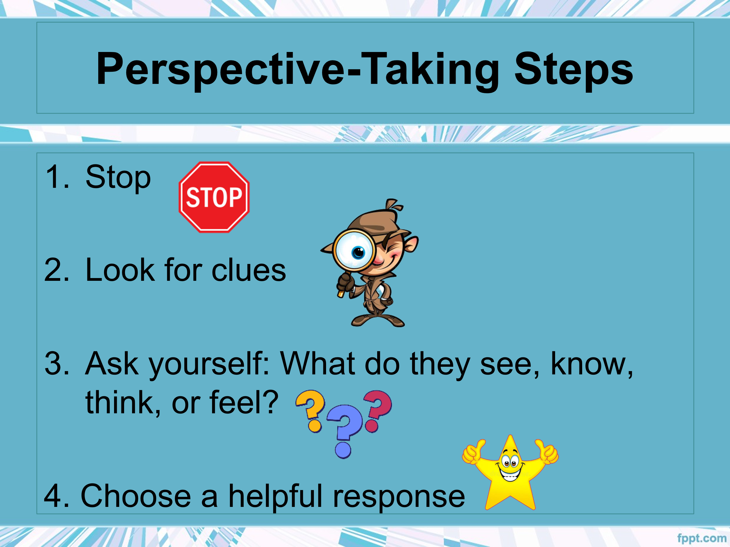
- So…what do you think?

- Get your magnet!

