What’s Happening Today?

Let’s Talk About Ways to Show We’re Listening

- Listening can look different for different people. We can show we’re listening with our eyes, body, words, or actions.

- Eye contact isn’t the only way to show that we’re listening. We can use quick glances or look toward the person.

- Looking toward the person helps us notice their body language and facial expressions that can help us decide what to do next.

- We can choose “listening looks” or “listening actions” to show that we’re paying attention to the speaker.

- There are different ways to show that we’re listening. We can choose a way that helps us feel comfortable.

- Look at eyes, somewhere on their face, or at a shared object
- Turn your body toward the speaker, nod your head, say “okay” or ask a question
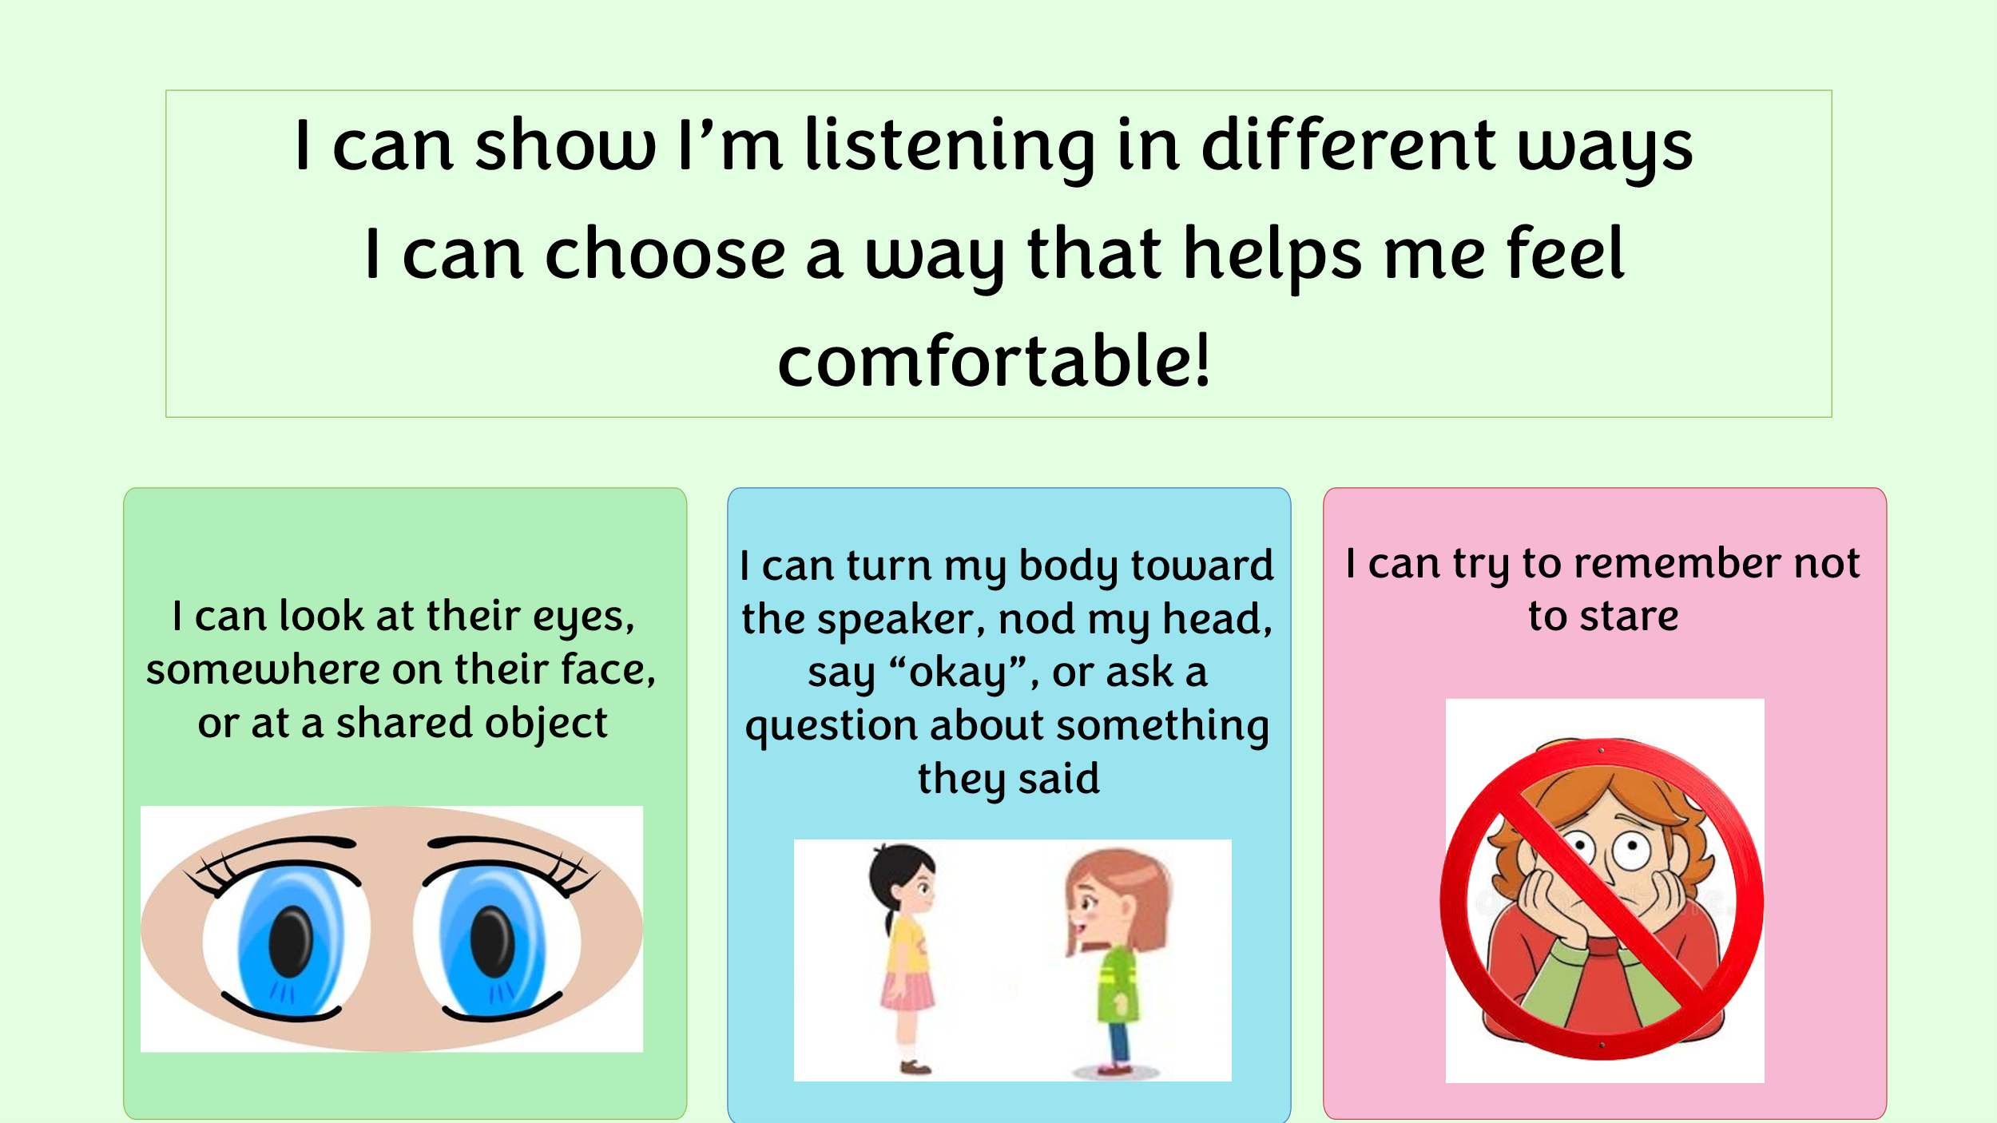
- Remember not to stare

- So…what do you think?

- Get your magnet!

