This week I might try:

To Show I’m Listening

I’ll try to show I’m listening in a way that helps me feel comfortable.

I can keep track of what I’m learning on the chart below:

I can: | Day  1 | Day  2 | Day  3 | Day  4 | Day  5
- Look at their eyes, somewhere on their face, or at a shared object.
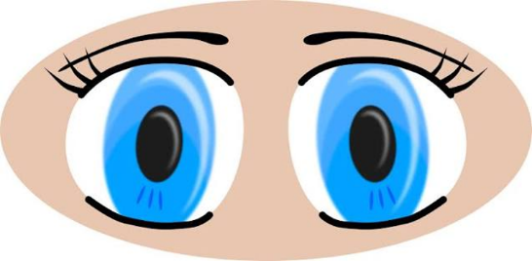

- Turn my body toward the speaker, nod my head, say “okay” or ask a question about something they said


- Try to remember not to stare






