What’s Happening Today?

Let’s Talk About Respecting Other People’s Things

- Everyone has special things that belong to them. What things are special to you?

- It’s important to treat other’s things with care and respect like we want others to treat our things.

- Respect means showing kindness and care to people and their belongings.

- Respecting other people’s things helps them feel happy and safe and helps you make and keep friends.

- 6 Ways to Respect Other People’s Things

- Ask permission
- Be careful
- Give items back
- Say “thank you”
- Respect privacy
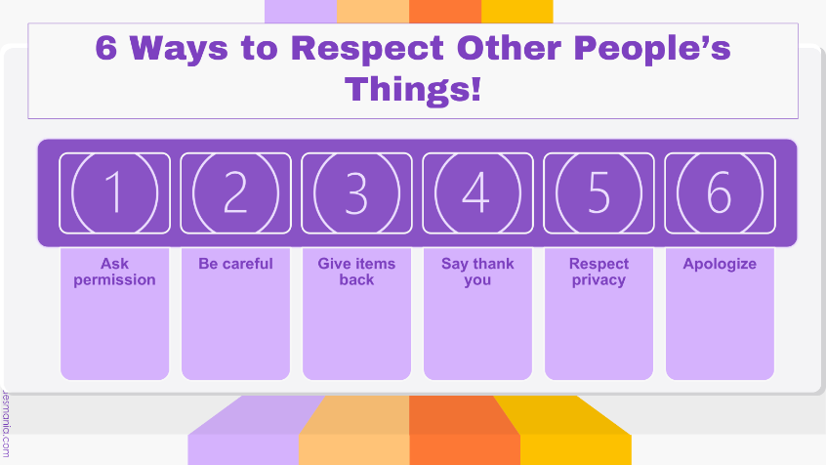
- Apologize

- So…what do you think?

- Get your magnet!

