This week I might try:

To Respect Other People’s Things

I’ll try to remember that it’s important to treat other people’s things with care and respect.
I can keep track of what I’m learning on the chart below:

I can: | Day  1 | Day  2 | Day  3 | Day  4 | Day  5
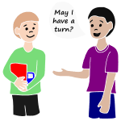
- Ask permission

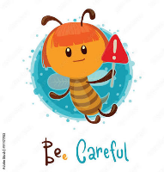
- Be careful


- Give items back

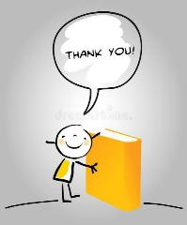
- Say “thank you"

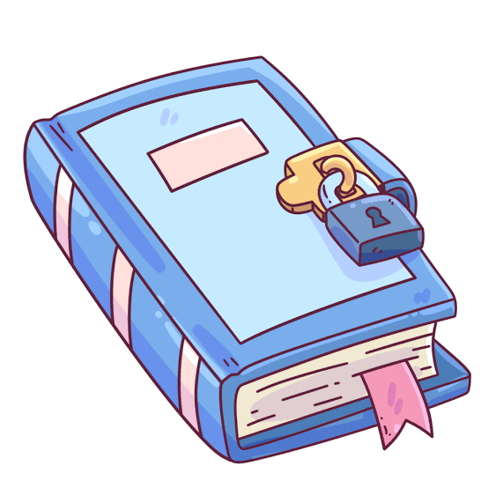
- Respect privacy

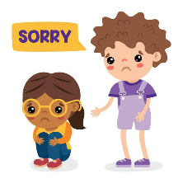
- Apologize



s

