
Social Skills –Parent Note

Your child just completed a social skills lesson. The topic was:
Instigator or Encourager?. Your knowledge of this lesson may help you to help your child generalize the skills to other environments.

What he/she learned:

- An Instigator is someone who tries to get others to do things that are unkind, unsafe, or against the rules; prompts others to make bad choices or to start trouble; tells a friend to break a rule or tease someone.
- An Encourager is someone who helps others do their best, make good choices, and feel good about themselves; uses kind words and actions to support their friends; cheers a friend on or helps others when they’re upset.

- Instigators can make people feel upset, nervous, or pressured

- Encouragers can make people feel happy, confident, and safe

- 4 Ways to Be an Encourager

- Say kind things to others
- Help people when they need it
- Invite others to join in activities
- Celebrate others’ successes

- So what do YOU think? discussion question
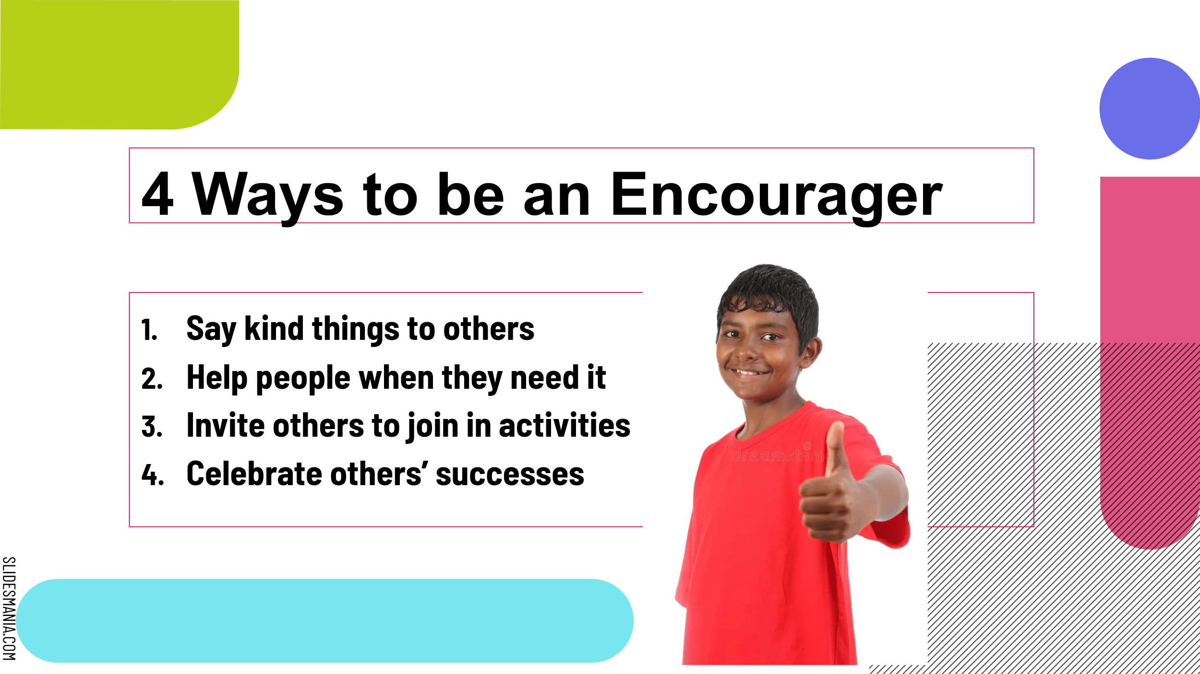

Your child received a Lesson Summary magnet:

If you have a moment, email _____________________________ with any information that might help your child for the next lesson on ________________________. THANK YOU!!

