What’s Happening Today?

Let’s Talk About Being an Instigator or an Encourager

- What does “being an instigator” mean?

- What does “being an encourager” mean?

- Let’s look at some examples and decide: Instigator or Encourager?

- How does an Instigator make others feel? How about an Encourager?

- 4 Ways to Be an Encourager

- Say kind things to others
- Help people when they need it
- Invite others to join in activities
- Celebrate others’ successes

- So…what do you think?
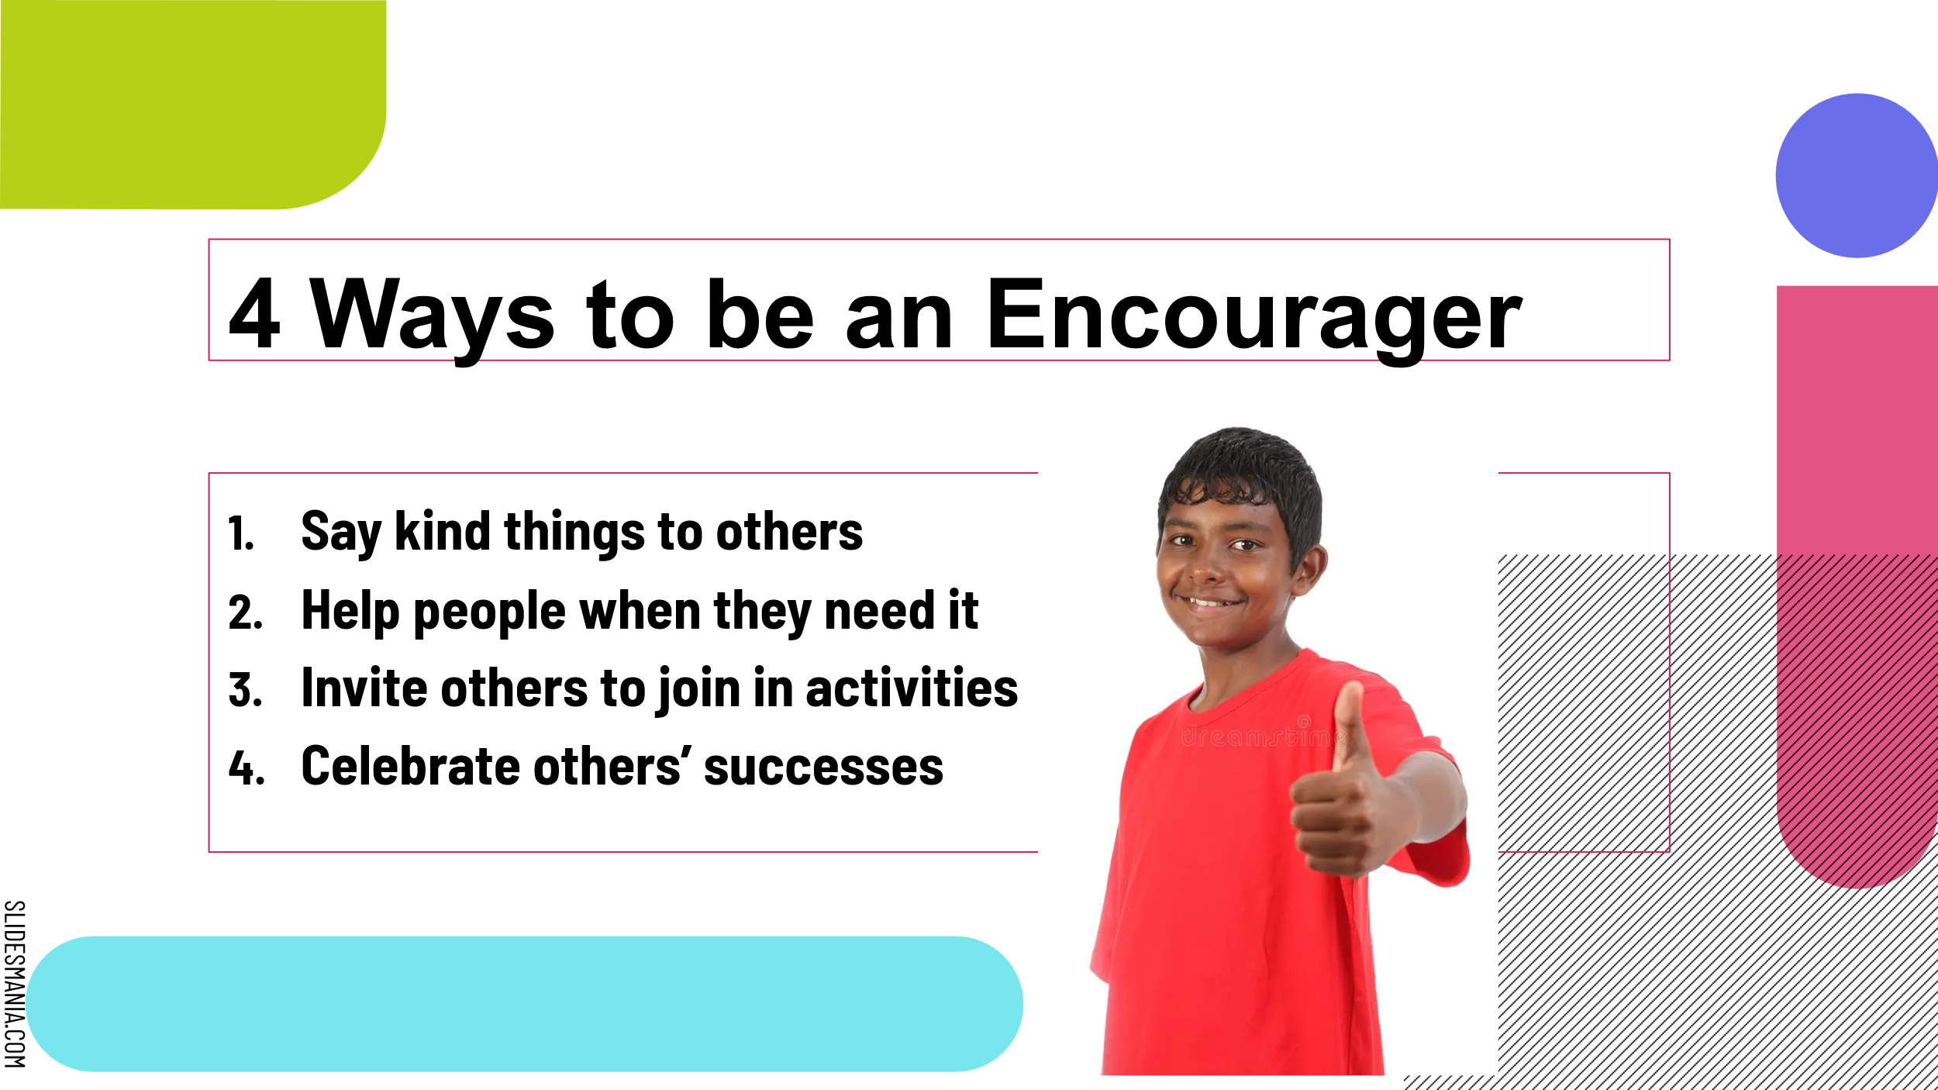
- Get your magnet!

