Me and My Diabetes…
So, I have diabetes

Sometimes I have to visit the nurse – That’s OK!!! I like Ms. Young. She is so nice to me.

How do I know when to go to the nurse?
- I go to the nurse at 10:00 AM 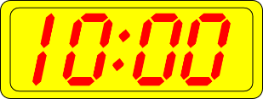
- I go to the nurse at 12:20 PM 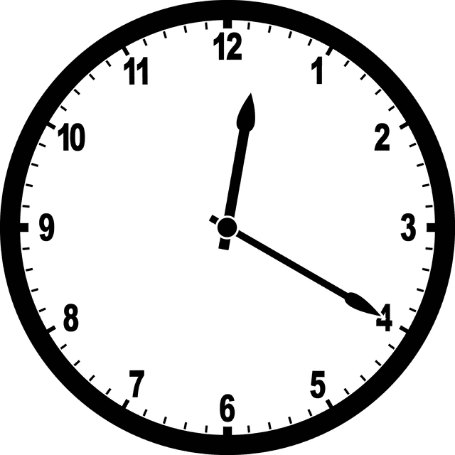
- I go to the nurse at 3:00 PM 

- I can also go to the nurse when I don’t feel quite right.
Sometimes I:
have “shaky legs” -- or I’m really hungry --- or really tired

- I also go to the nurse when my teacher asks me to. Sometimes my teacher notices that I am very cranky or am not acting like my happy self.

– She will ask me to go check with the nurse. My teacher just wants what is best for me. I will try to listen and go right away.
Ms. Young has it all figured out. She says that it only takes ___ minutes when I cooperate and do everything without complaining.
I can do this – My teacher, the nurse and my friends will help.

