
Social Skills –Parent Note

Your child just completed a social skills lesson. The topic was:
I Can Handle Scary Weather. Your knowledge of this lesson may help you to help your child generalize the skills to other environments.

What he/she learned:

- Different kinds of weather can be scary (lightning, thunder, heavy rains, etc.)

- Being scared can make our bodies feel different.

- It’s okay to feel scared. There are things we can do to help us when we feel scared.

- 5 Strategies to Handle Scary Weather

- Stay safe
- Listen to grown-ups
- Ask for help if you need it
- Do something to feel more comfortable
- Practice calming strategies

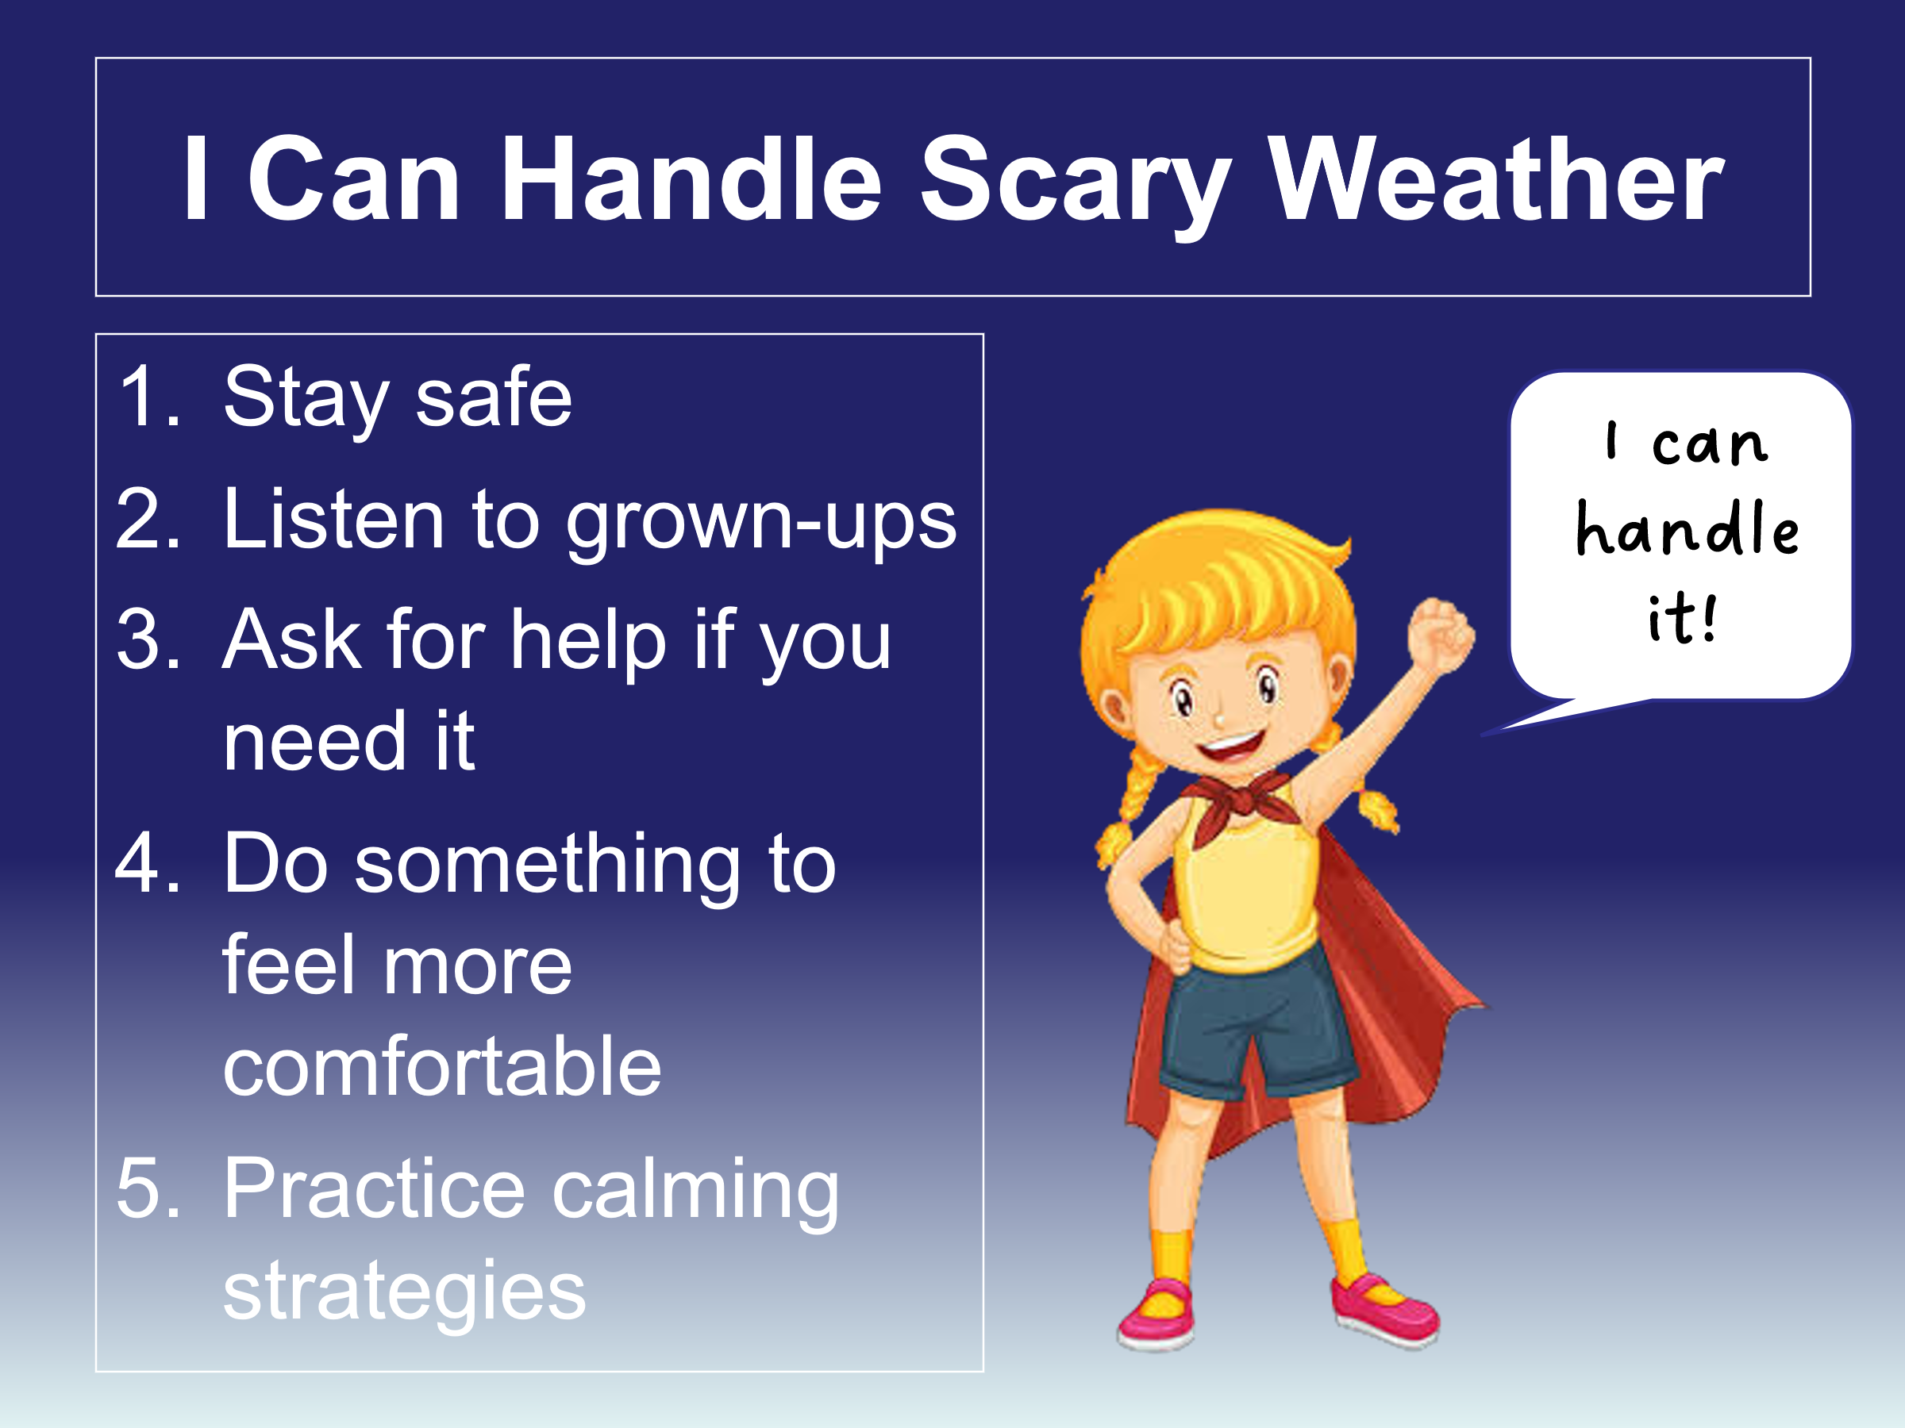
- So what do YOU think? discussion question

Your child received a Lesson Summary magnet:

If you have a moment, email _____________________________ with any information that might help your child for the next lesson on ________________________. THANK YOU!!

