What’s Happening Today?

Let’s Talk About What to do
When the Weather is Scary

- Sometimes the weather can be scary

- There can be lightning, thunder, heavy rain, etc.

- It’s okay to be scared. Our bodies feel differently when we’re scared.

- 5 Things to Try When the Weather is Scary

- Stay safe
- Listen to grown-ups
- Ask for help if you need it
- Do something to feel more comfortable
- Practice calming strategies

- So…what do you think?
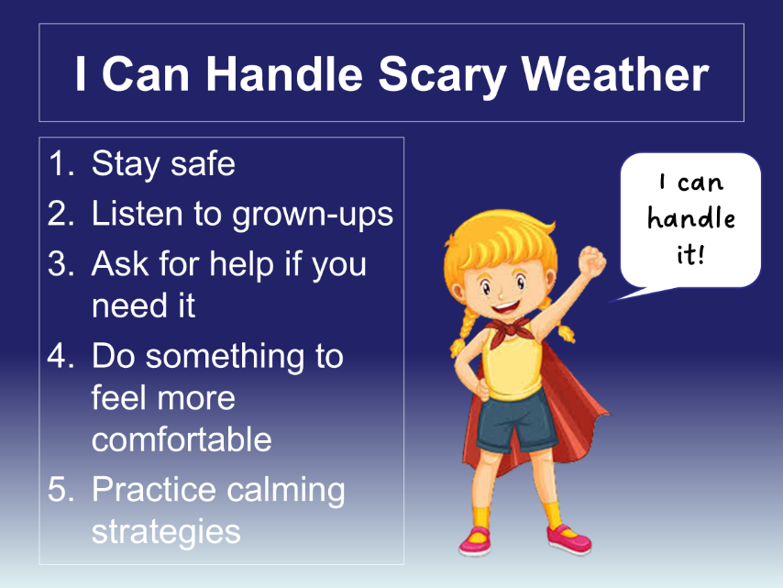
- Get your magnet!

