This week I might try:

To handle scary weather

I’ll try to remember what to do when the weather is scary.
I can keep track of what I’m learning on the chart below:

I can: | Day  1 | Day  2 | Day  3 | Day  4 | Day  5
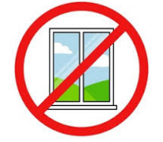
- Stay safe

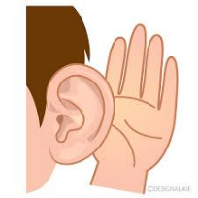
- Listen to grown-ups


- Ask for help if you need it


- Do something to feel more comfortable


- Practice calming strategies




