
Social Skills –Parent Note

Your child just completed a social skills lesson. The topic was:
I Can Be Kind to Animals. Your knowledge of this lesson may help you to help your child generalize the skills to other environments.

What he/she learned:

- Being kind to animals means treating animals with care and respect, being gentle and friendly, and taking care of their needs.

- Being kind to animals is important because it helps build trust and friendship with them.

- Animals have emotions – just like people. Being kind helps them feel safe and happy.

- 5 Ways to Be Kind to Animals

- Use a soft voice and gentle touch
- Feed healthy food and clean water every day
- Never hurt animals or tease them
- Tell an adult if an animal is hurt or lost
- Give animals space when they need it

- So what do YOU think? discussion question

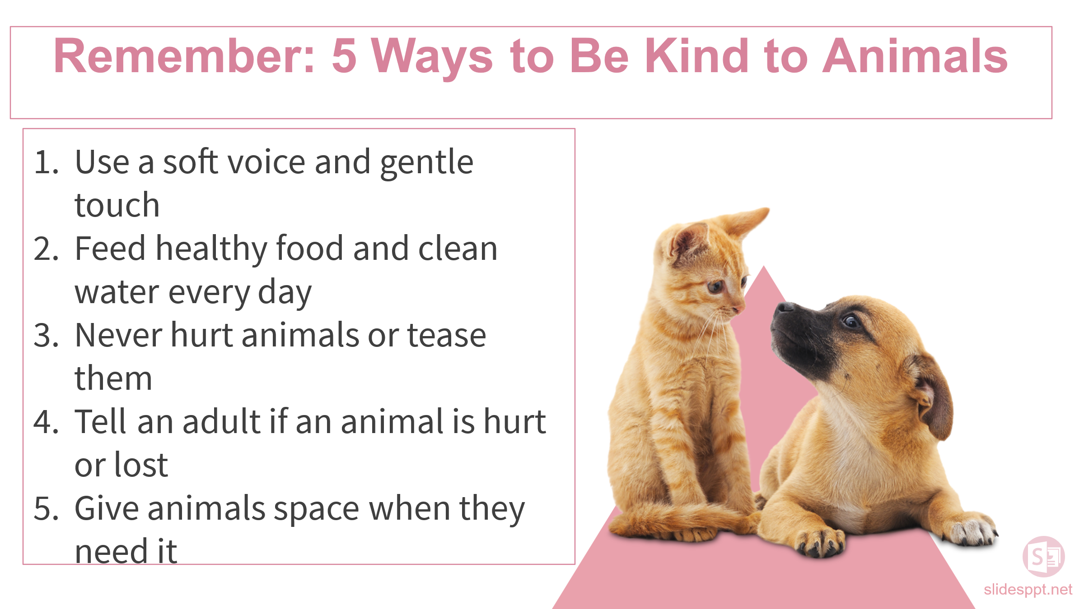
Your child received a Lesson Summary magnet:

If you have a moment, email _____________________________ with any information that might help your child for the next lesson on ________________________. THANK YOU!!

