What’s Happening Today?

Let’s Talk About Being Kind to Animals

- What does “being kind” mean? How do you feel when someone is kind to you?

- Animals have emotions – just like people.

- It’s important to be kind to animals so that they trust us.

- 5 Ways to Be Kind to Animals

- Use a soft voice and gentle touch
- Feed healthy food and clean water every day
- Never hurt animals or tease them
- Tell an adult if an animal is hurt or lost
- Give animals space when they need it

- So…what do you think?

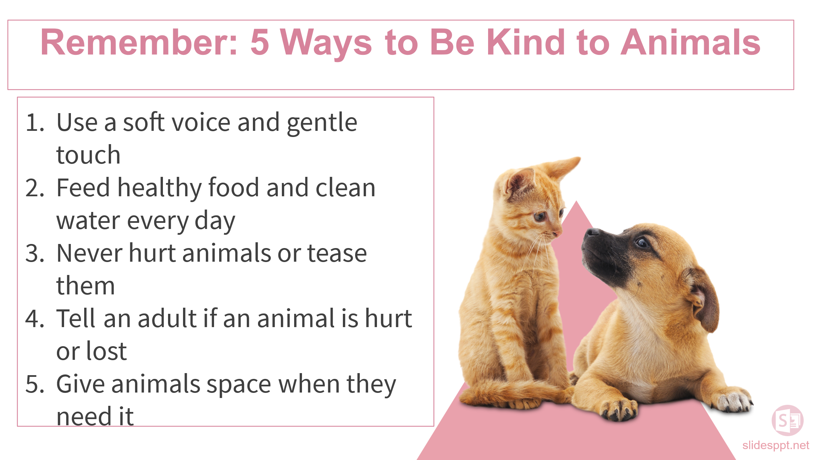
- Get your magnet!

