
Social Skills – Teacher Note

Your student just completed a social skills lesson. The topic was:
I Can Accept Change. Your knowledge of this lesson may help you to help your student generalize the skills to other environments.

What they learned:

- Change is when something becomes different

- There are BIG changes and LITTLE changes. Some are PLANNED and some are UNEXPECTED

- People can have different feelings about change and that’s okay!

- Learning how to accept change is important because it’s part of life

- 6 Tips for Accepting Change

- Ask questions
- Talk about your feelings
- Practice calming strategies
- Make a plan
- Focus on the positive
- Give yourself time

- So what do YOU think? discussion question

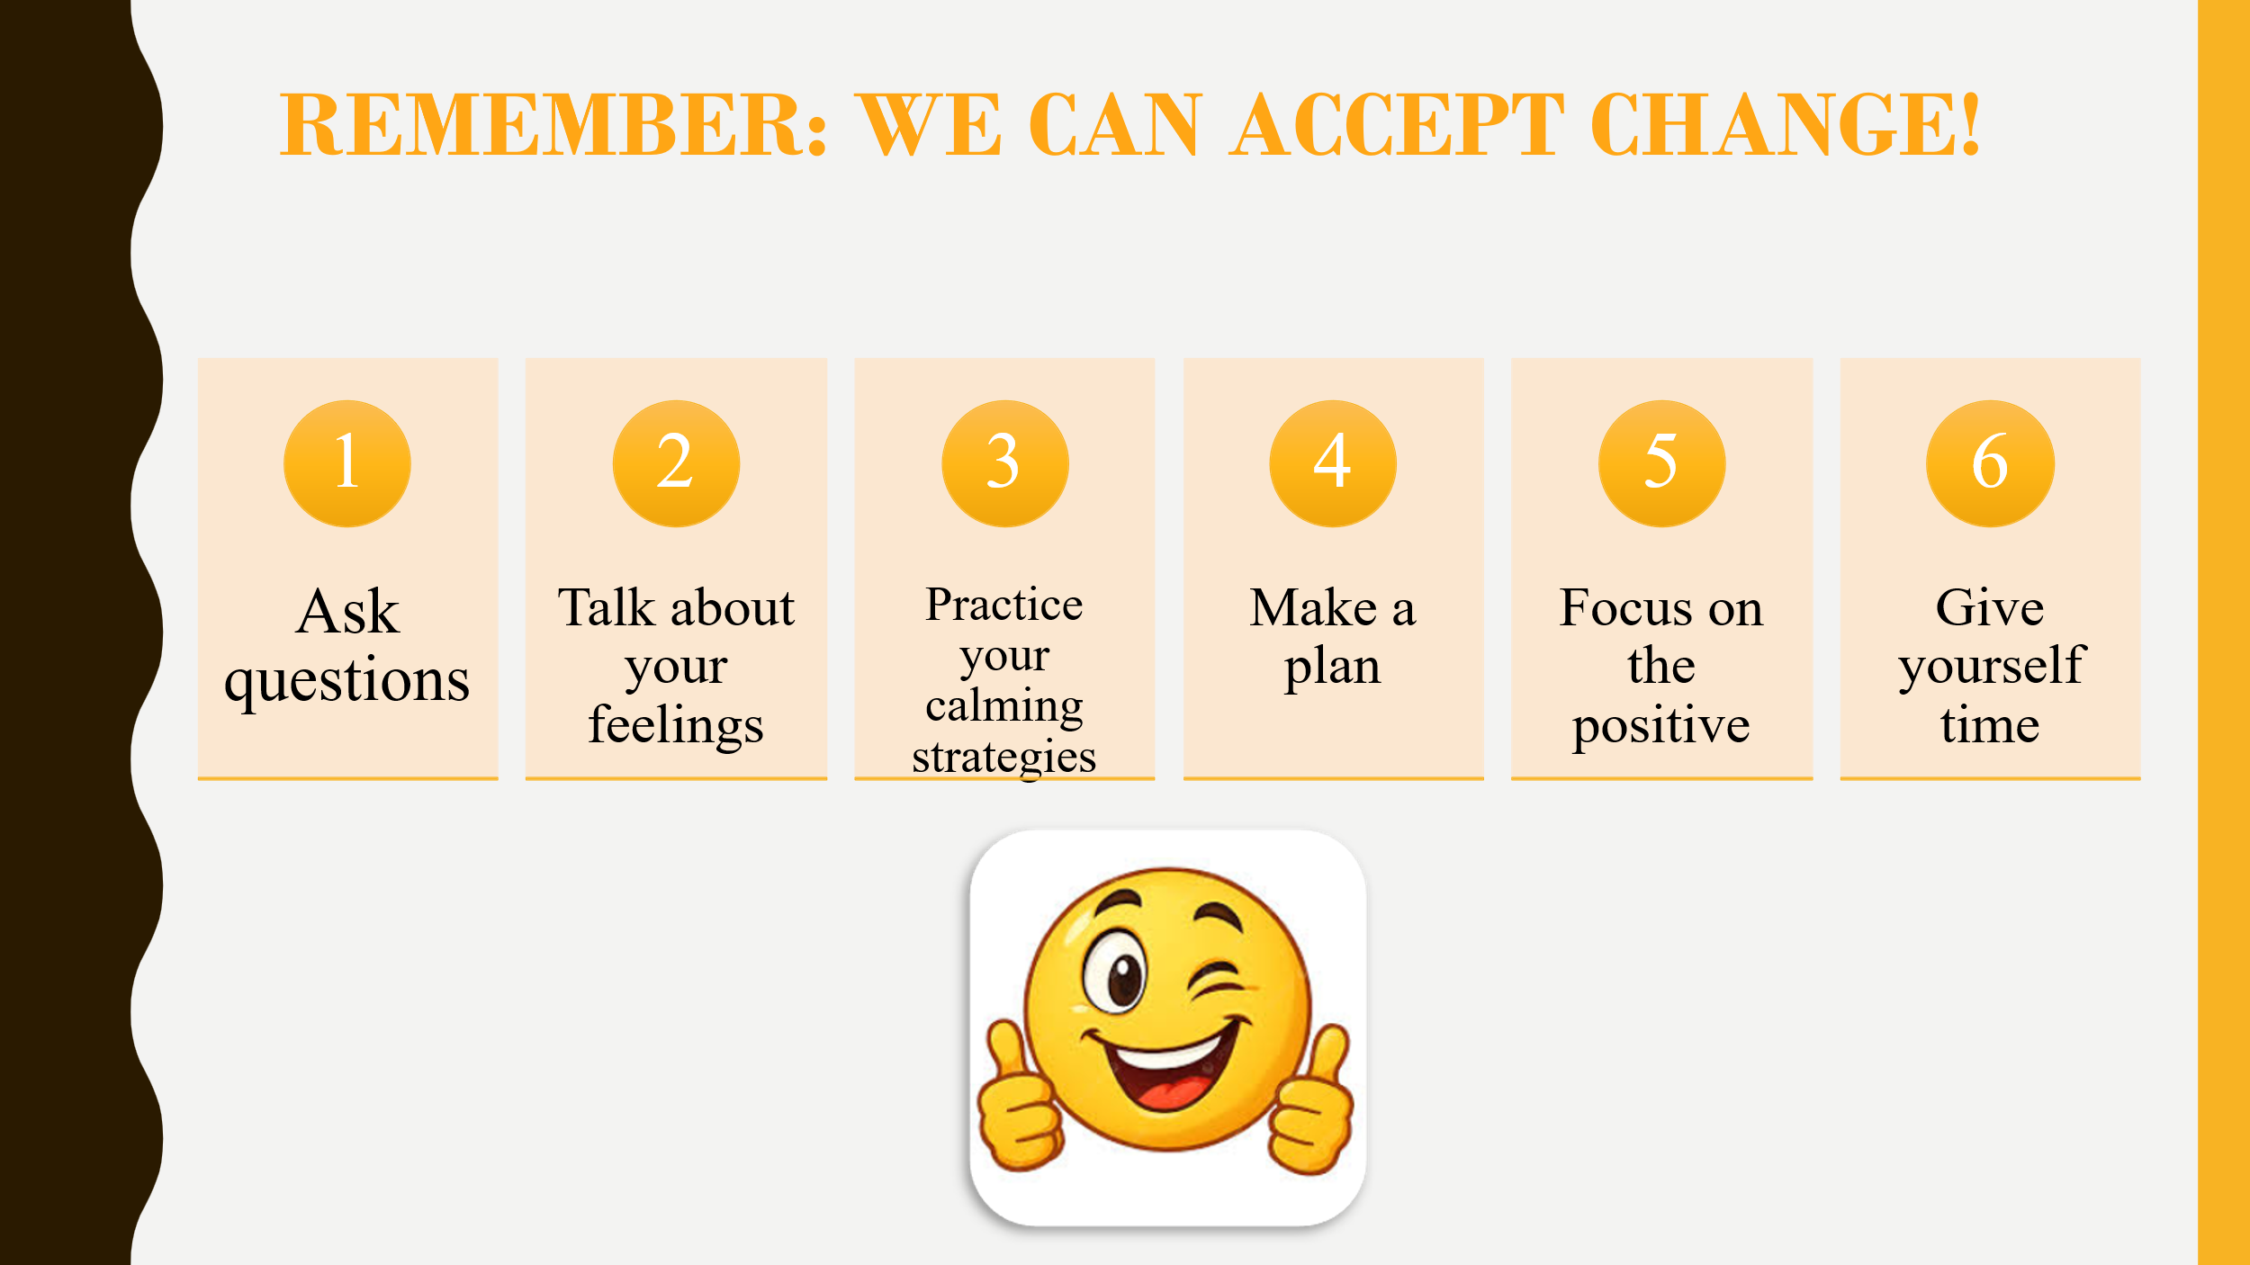
Your student received a Lesson Summary magnet:

If you have a moment, email _____________________________ with any information that might help your student for the next lesson on ________________________. THANK YOU!!

