
Social Skills –Teacher Note

Your student just completed a social skills lesson. The topic was:
What to do When I Can’t Get My Way. Your knowledge of this lesson may help you to help your student generalize the skills to other environments.

What he/she learned:

- Sometimes things don’t work out the way we want

- That can make us feel frustrated, sad, mad, or disappointed

- Since we can’t always get what we want, it’s important that we learn how to handle our feelings

- There are 6 tips for handling our feelings when we can’t get what we want

- Remember: When You Can’t Get Your Way

- Take a deep breath
- Use positive self-talk
- Ask for help
- Think of other options
- Practice waiting
- Talk about your feelings

- So what do YOU think? discussion question

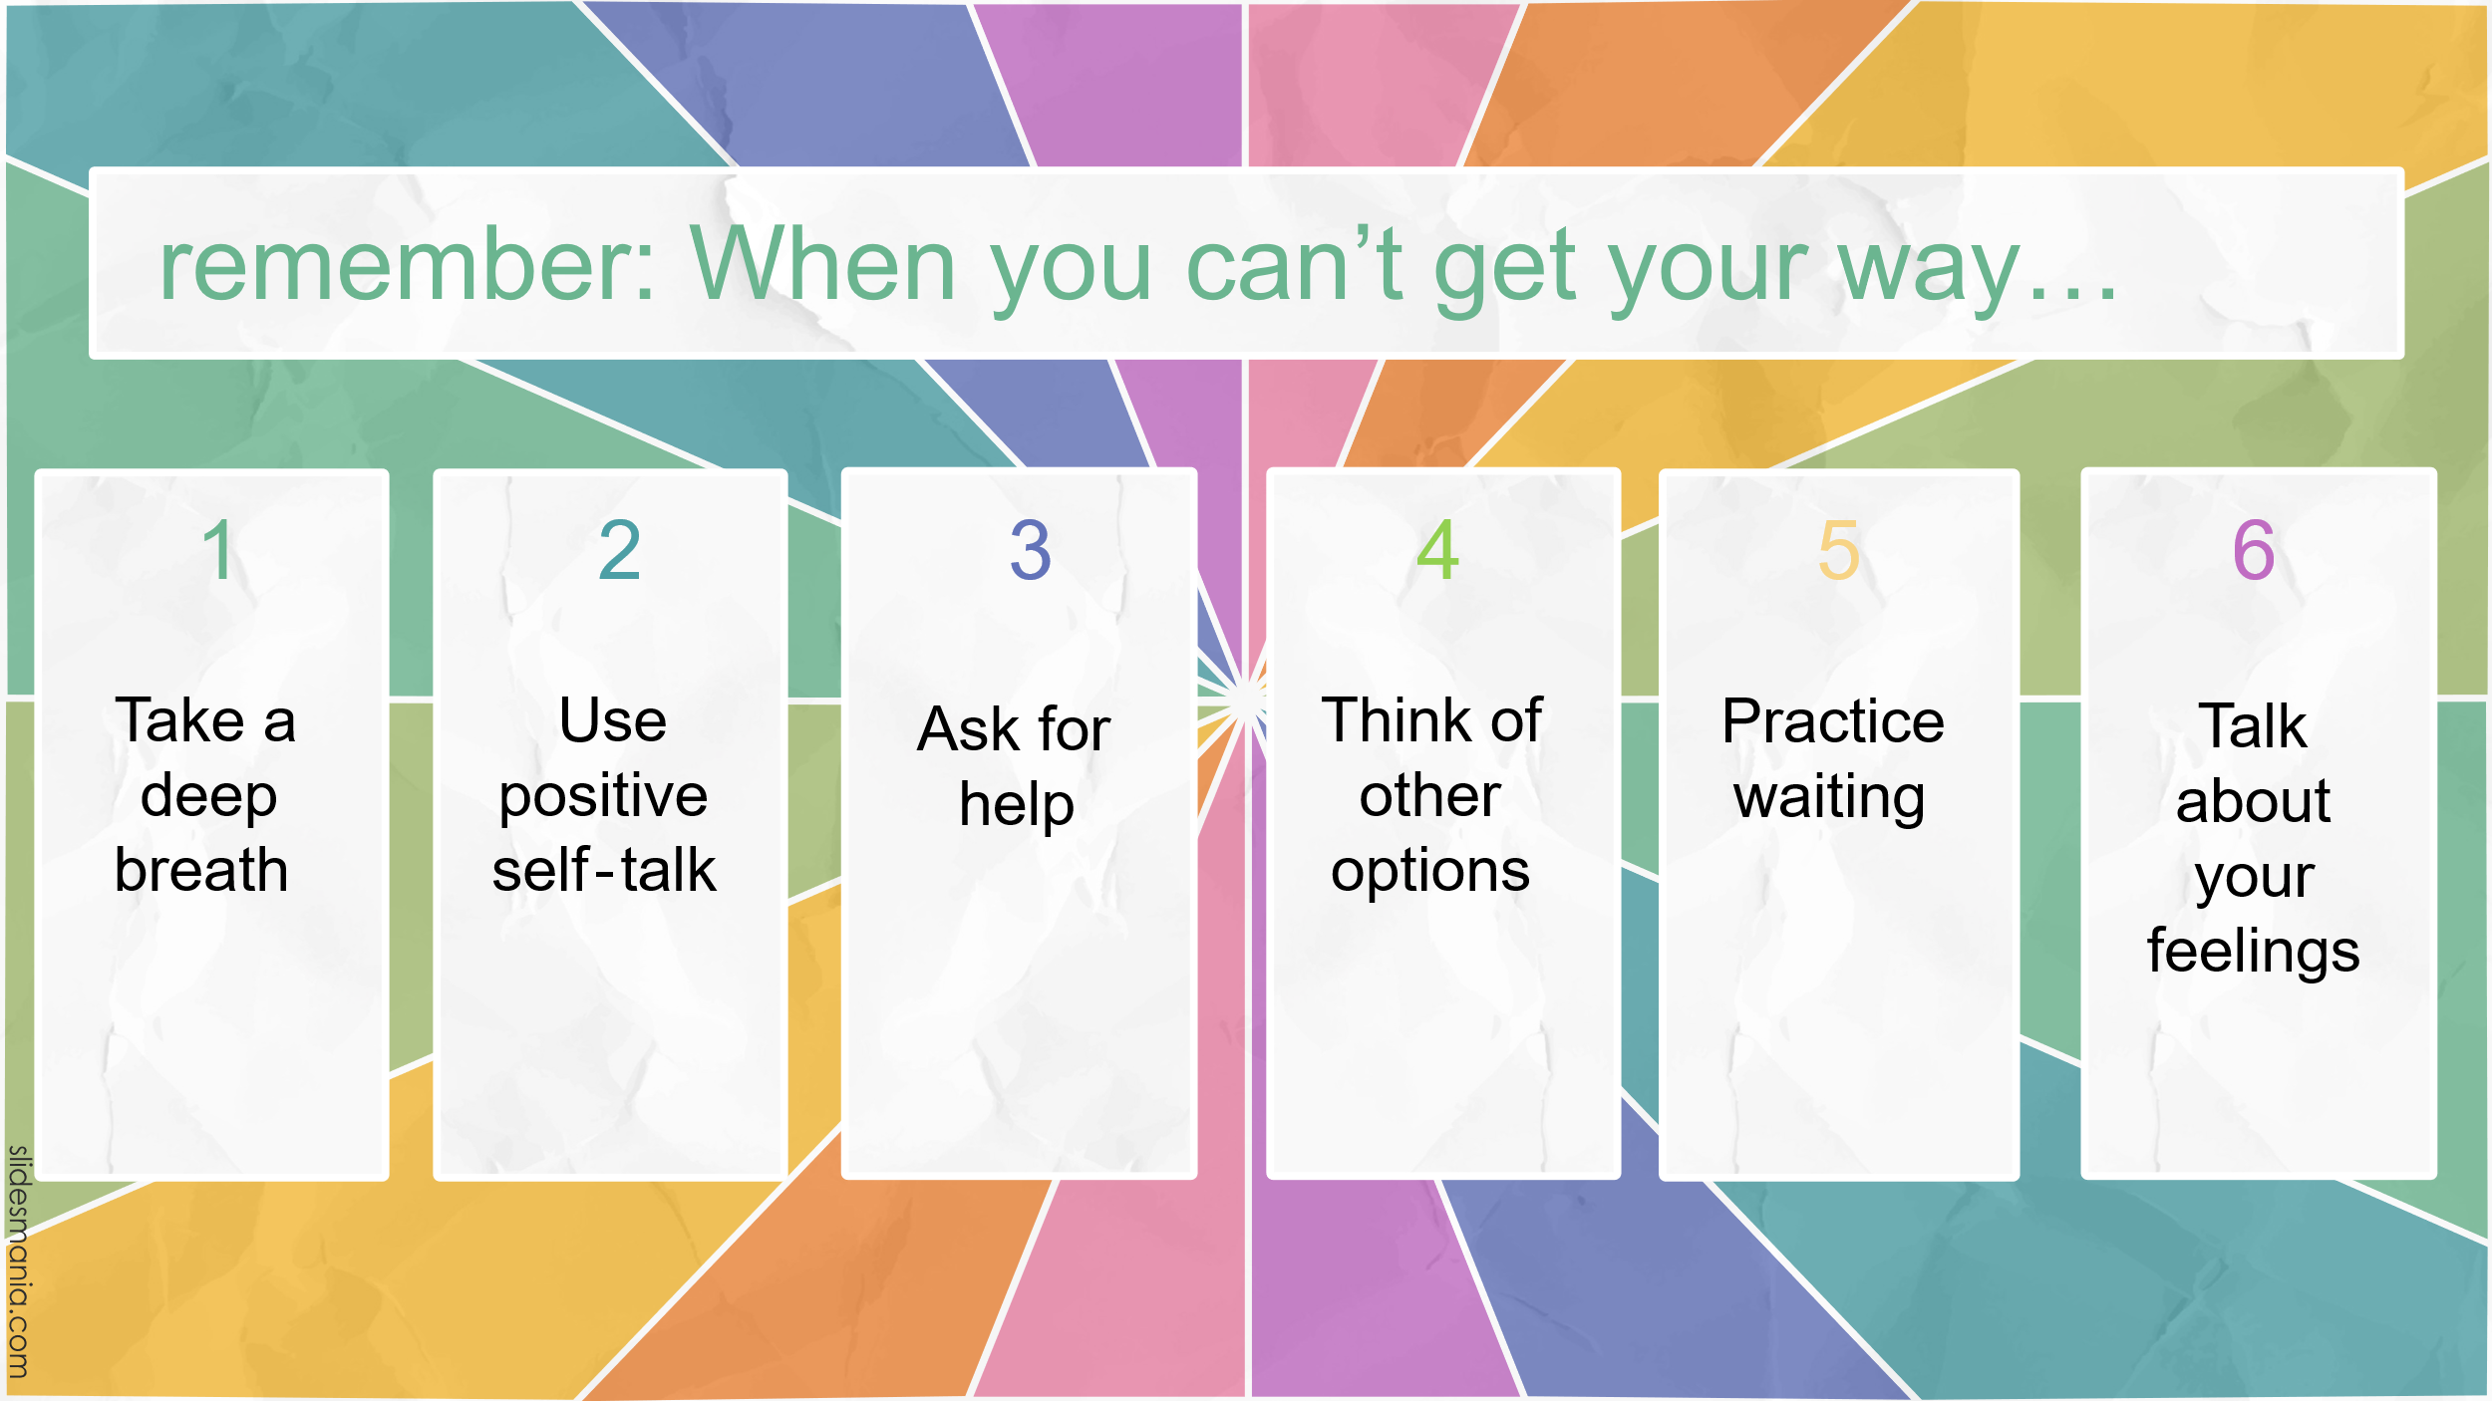
Your student received a Lesson Summary magnet:

If you have a moment, email _____________________________ with any information that might help your student for the next lesson on ________________________. THANK YOU!!

