What’s Happening Today?

Let’s Talk About What to do When You Can’t Get Your Way

- Sometimes we want something we can’t have

- That can make us sad, frustrated, mad, or disappointed

- It’s important to learn how to handle our feelings when we can’t get our way

- 6 Things to Try When You Can’t Get Your Way

- Take a deep breath
- Use positive self-talk
- Ask for help
- Think of other optioms
- Practice waiting
- Talk about your feelings

- So…what do you think?
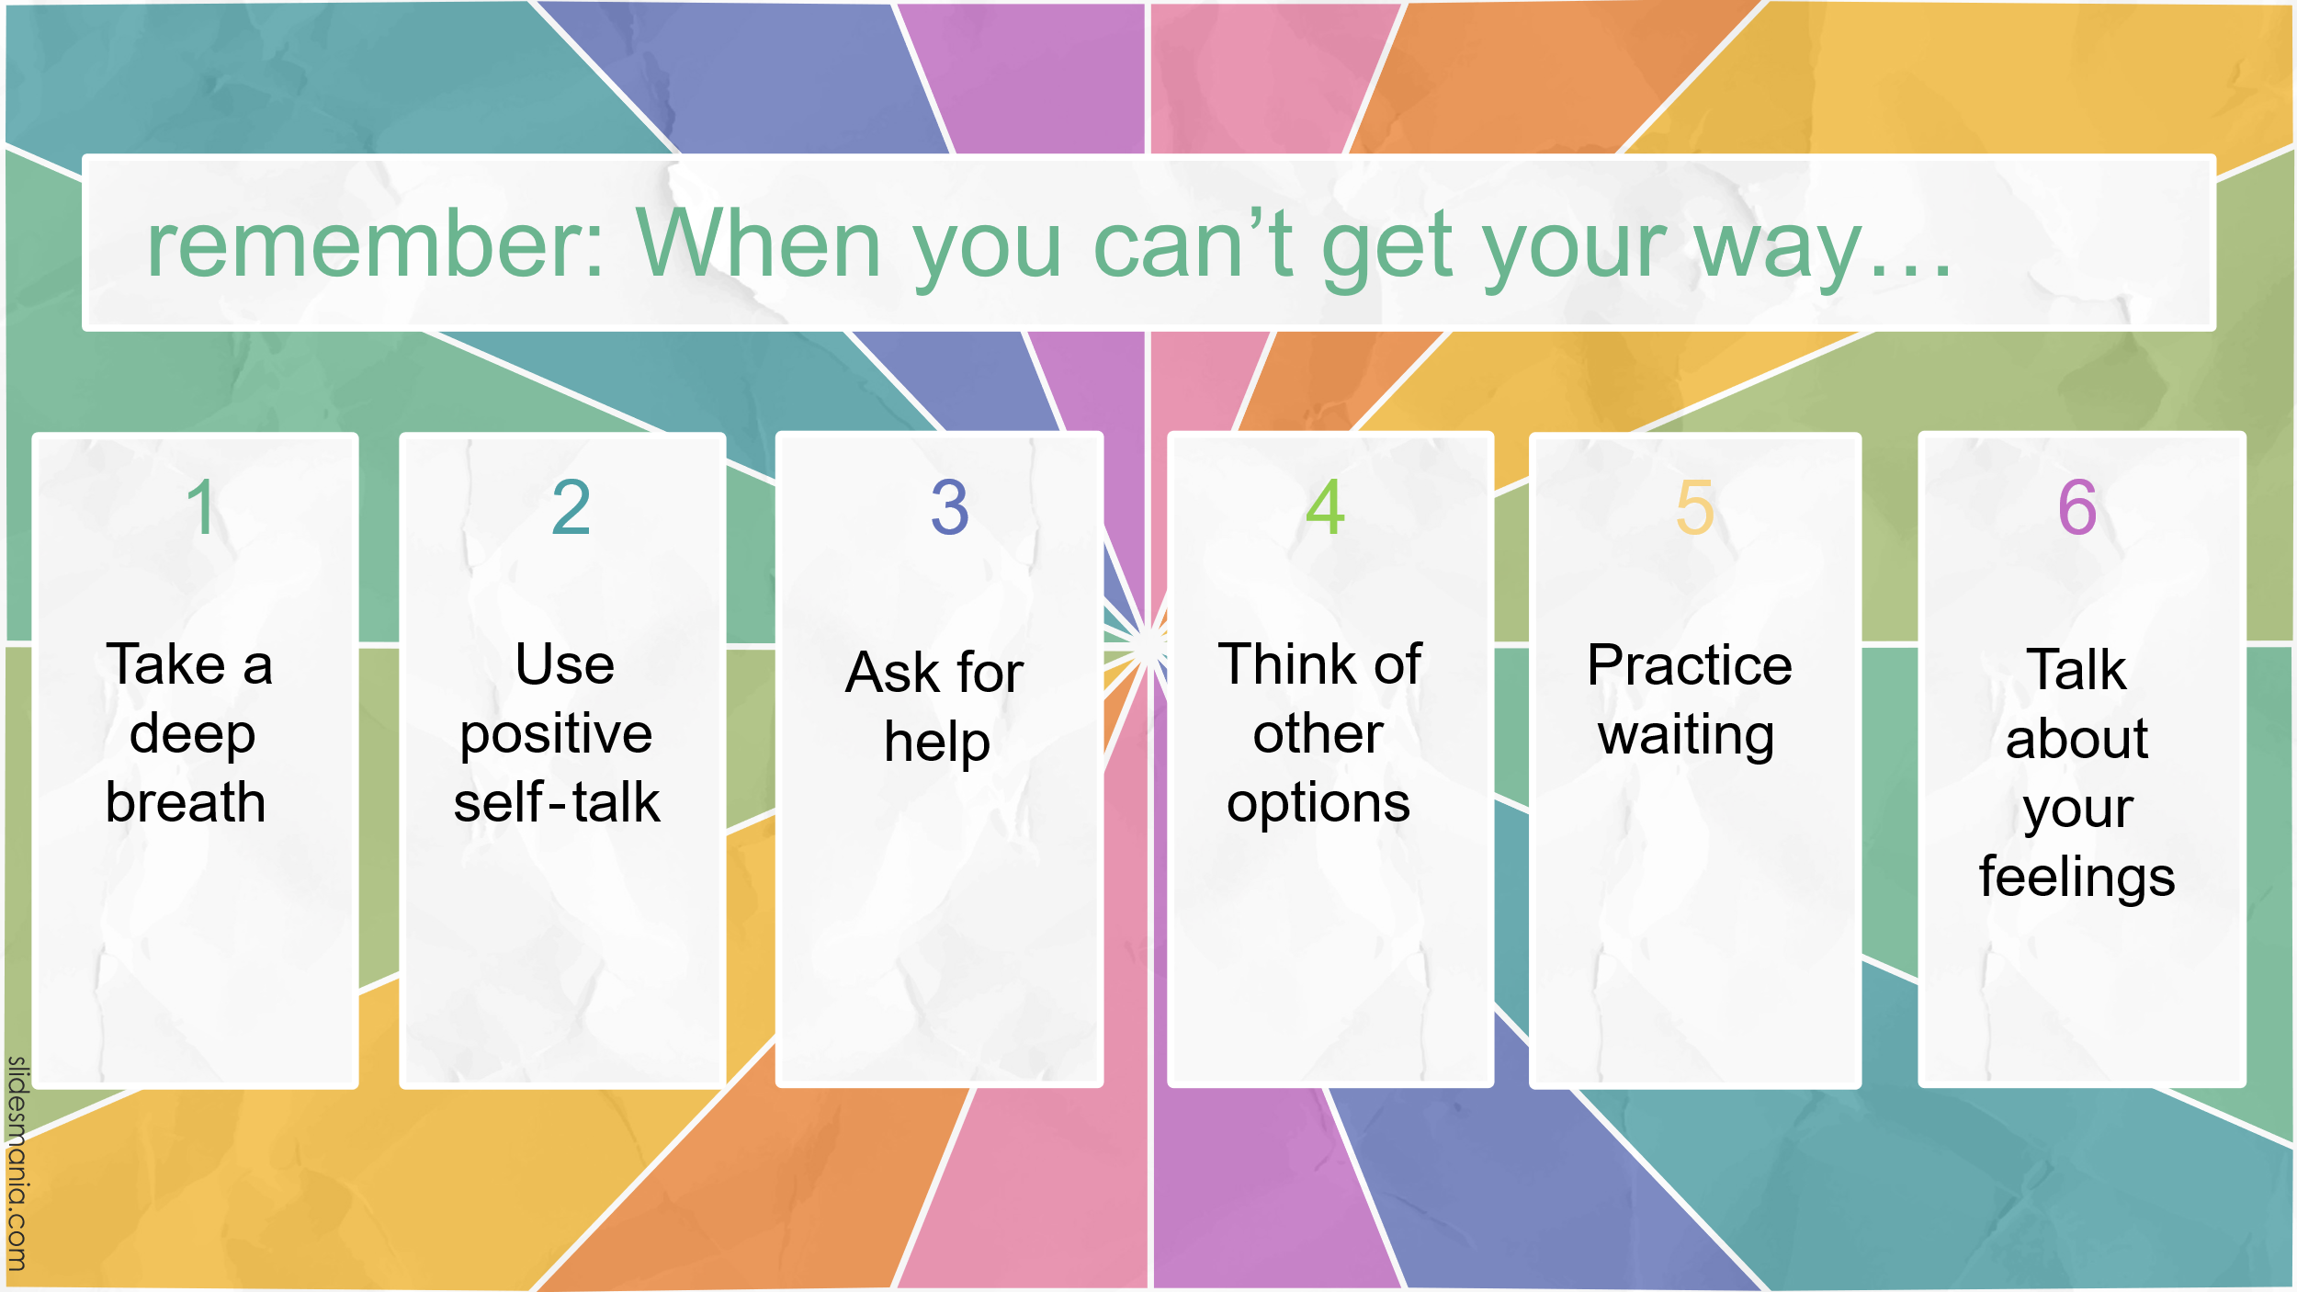
- Get your magnet!

