This week I might try:

To handle not getting my way

I’ll try to remember that I can’t always get what I want and there are things I can do to help me.
I can keep track of what I’m learning on the chart below:

I can: | Day  1 | Day  2 | Day  3 | Day  4 | Day  5

- Take a deep breath

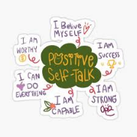
- Use positive self-talk


- Ask for help


- Think of other options


- Practice waiting


- Talk about my feelings




