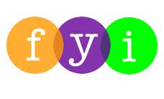
Social Skills –Parent Note

Your child just completed a social skills lesson. The topic was:
I Know What to Do When I’m Sick. Your knowledge of this lesson may help you to help your child generalize the skills to other environments.

What he/she learned:

- We all get sick sometimes. There are different kinds of illness: stomach ache, ear ache, runny nose, sore throat, etc.

- Practicing good “health hygiene” can help us feel better faster and keep us from getting others sick

- Health hygiene is taking care of ourselves through cleanliness and other good habits to prevent us from spreading germs

- 5 Things to do When I’m Sick

- Cover coughs and sneezes
- Wash hands often
- Stay home when needed
- Don’t share personal items
- Ask for help

- So what do YOU think? discussion question
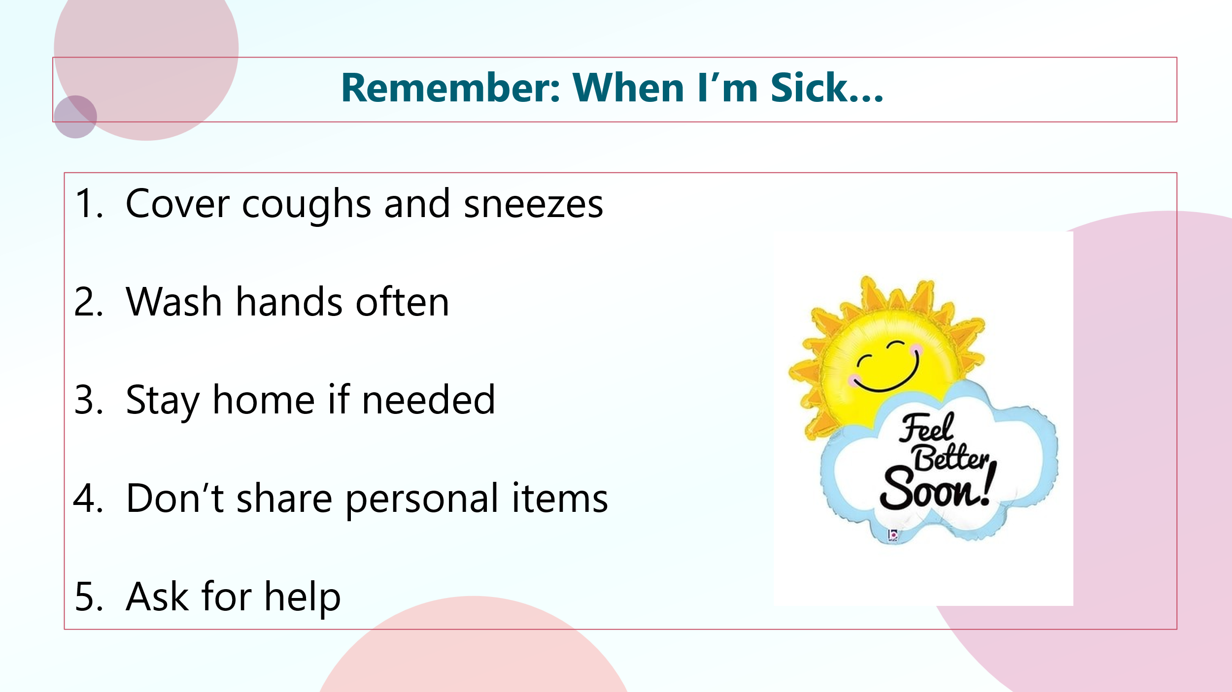

Your child received a Lesson Summary magnet:

If you have a moment, email _____________________________ with any information that might help your child for the next lesson on ________________________. THANK YOU!!

