What’s Happening Today?

Let’s Talk About What to Do When You’re Sick

- When we get sick, we have to take care of ourselves

- What is “health hygiene”?

- Health hygiene is important so we don’t spread germs to others. It can also help us get better faster

- 5 Things to Do When I’m Sick

- Cover coughs and sneezes
- Wash hands often
- Stay home if needed
- Don’t share personal items
- Ask for help

- So…what do you think?

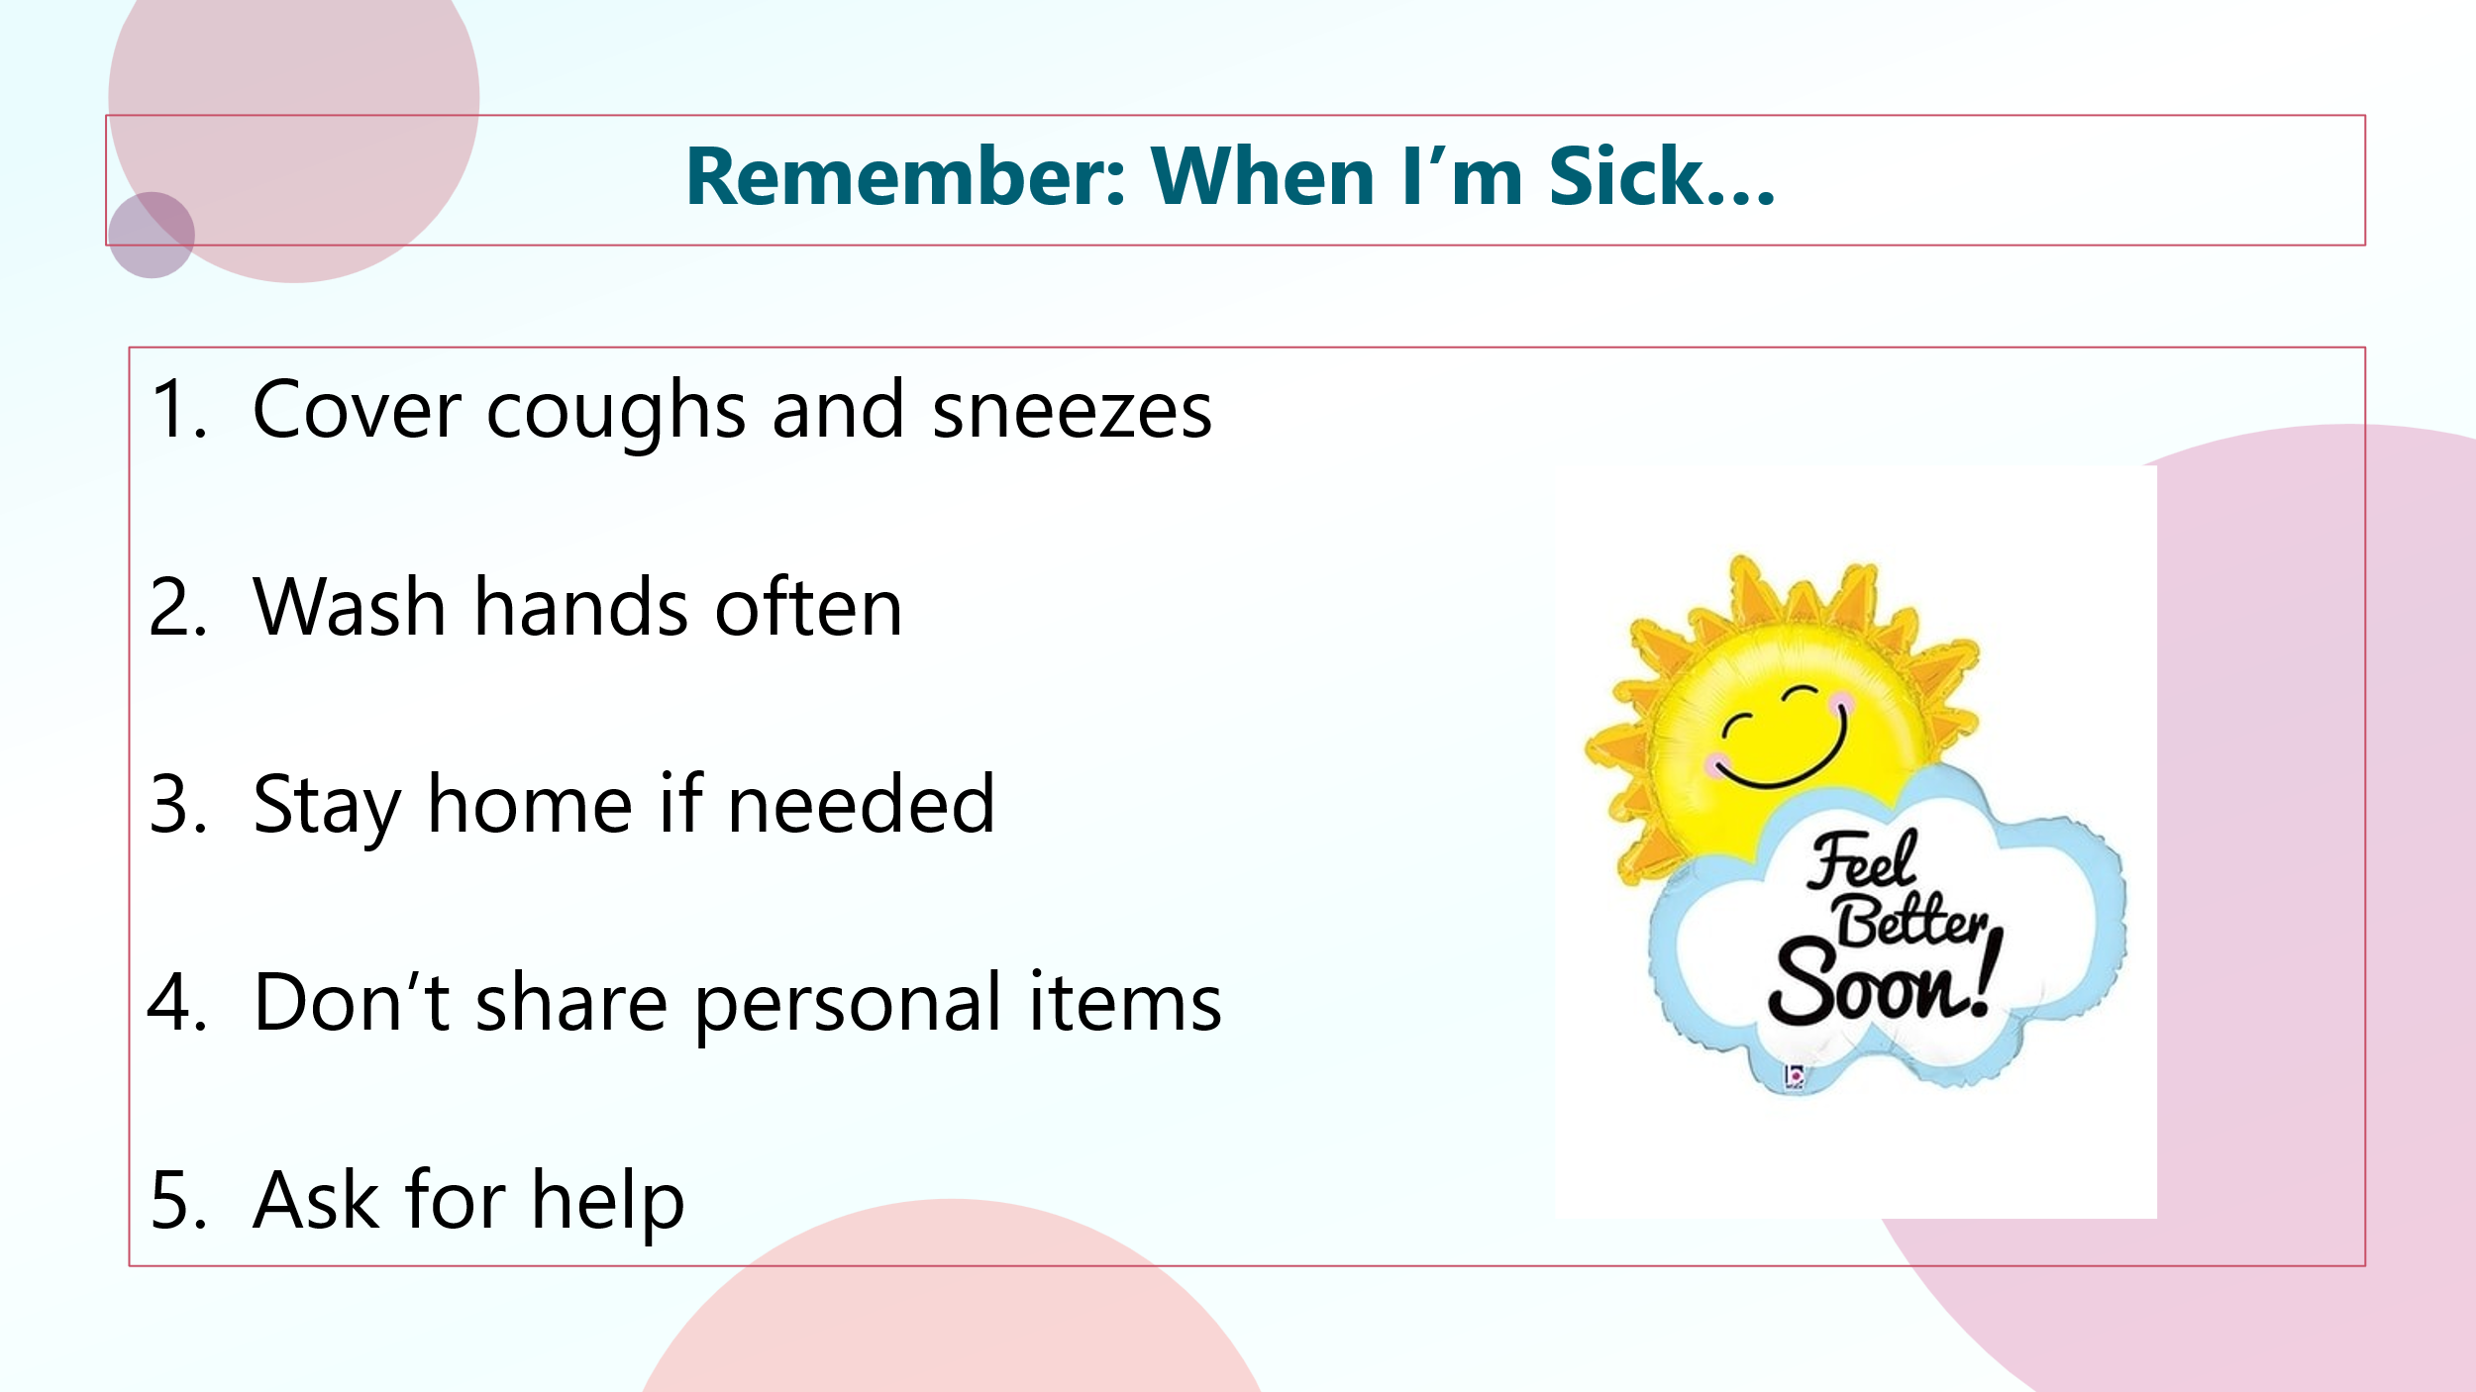
- Get your magnet!

