This week I might try:

To Take Care of Myself When I’m Sick

I’ll try to remember that there are things I can do when I’m not feeling well.
I can keep track of what I’m learning on the chart below:

I can: | Day  1 | Day  2 | Day  3 | Day  4 | Day  5
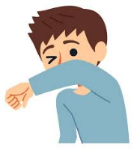
- Cover my coughs and sneezes


- Wash my hands often

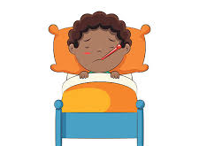
- Stay home if needed

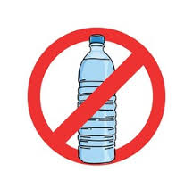
- Don’t share personal items

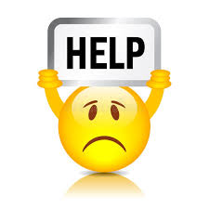
- Ask for help



