
Social Skills –Teacher Note

Your student just completed a social skills lesson. The topic was:
I Can Keep My Clothes on at School. Your knowledge of this lesson may help you to help your student generalize the skills to other environments.

What he/she learned:

- We wear clothes to keep warm, comfortable, and to keep our bodies private

- Everyone wears clothes at school!

- It can make people uncomfortable when I take my clothes off at school

- I can take my clothes off at home in private spaces (bedroom, bathroom)

- If my clothes are uncomfortable (itchy, too hot, socks are bunched up, wet) I can ask a teacher for help

- 4 Things to Remember:

- Clothes stay ON at school
- We wear clothes to keep warm, stay comfortable, and to keep our bodies private
- If my clothes are uncomfortable, I can ask for help
- Clothes can come off at home in private spaces

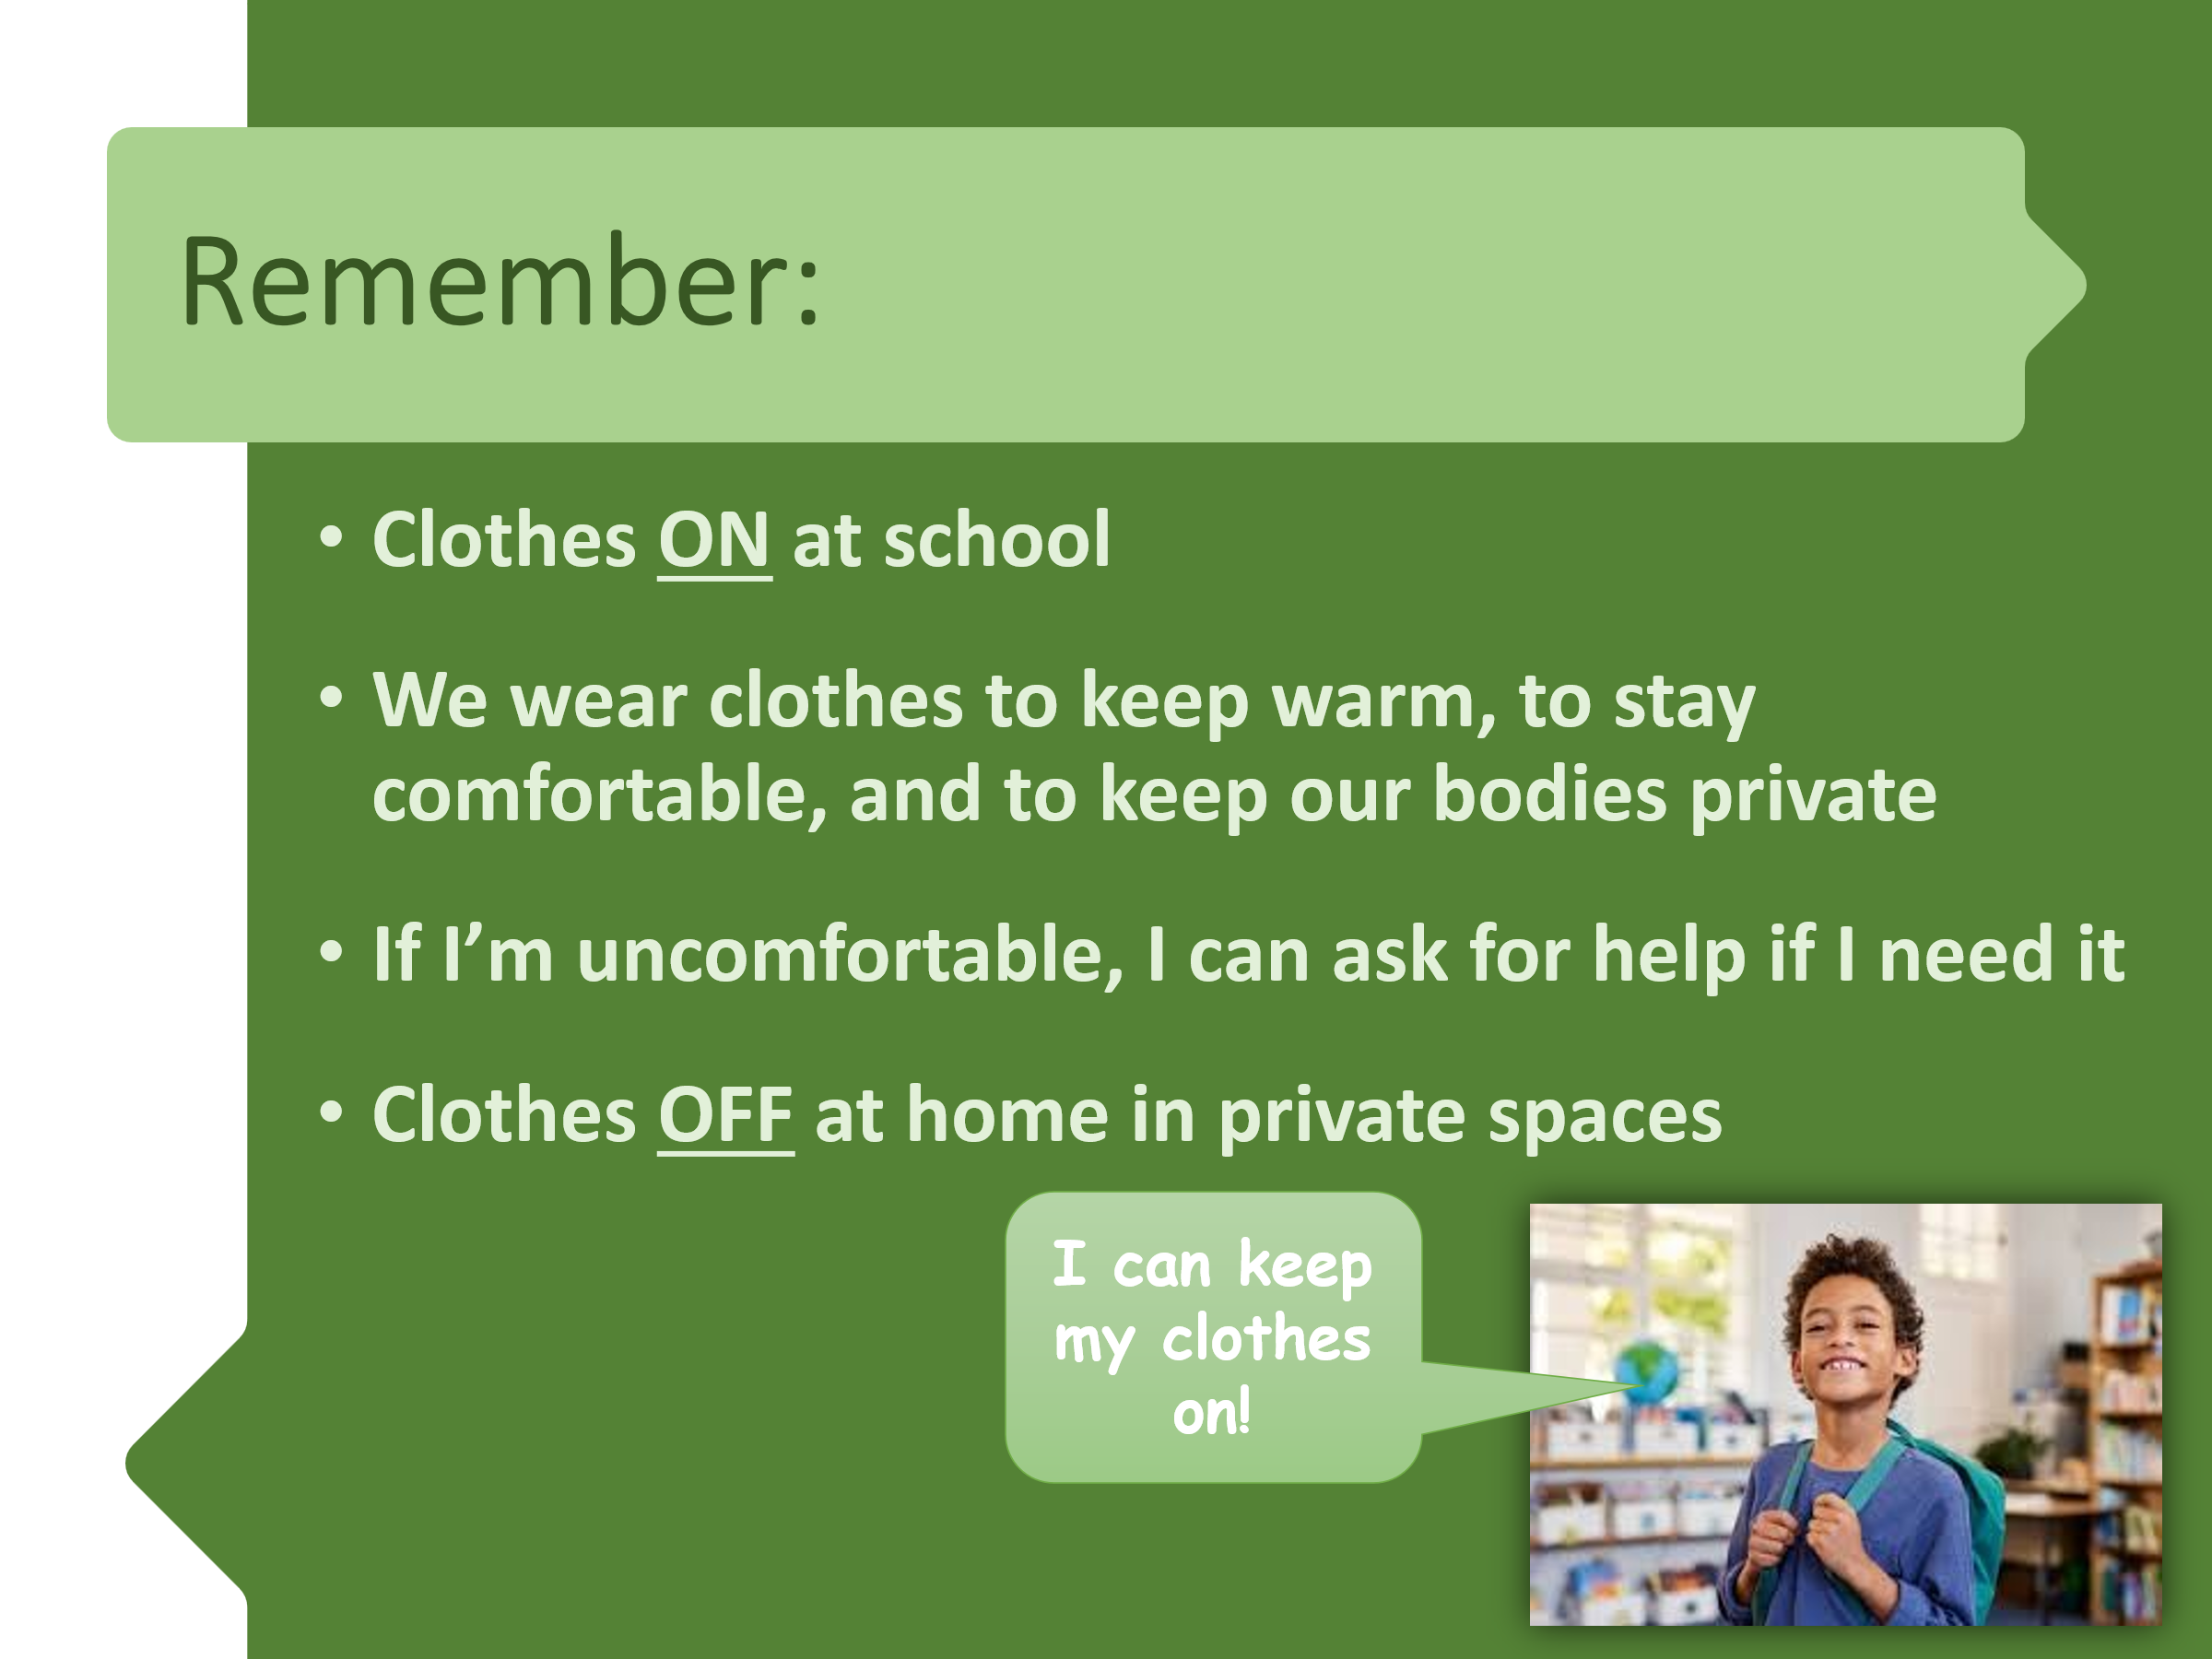
- So what do YOU think? discussion question

Your student received a Lesson Summary magnet:

If you have a moment, email _____________________________ with any information that might help your student for the next lesson on ________________________. THANK YOU!!

