What’s Happening Today?

Let’s Talk About Keeping Clothes on at School

- When we’re at school, our clothes need to stay on

- We wear clothes to keep warm, be comfortable, and to keep our bodies private

- Sometimes our clothes may bother us. We can ask a teacher for help.

- 4 Things to Remember About Keeping Clothes on at School

- Clothes stay on at school
- We wear clothes to keep warm, comfortable, and to keep our bodies private
- Ask for help if my clothes bother me
- Clothes can come off at home in private spaces

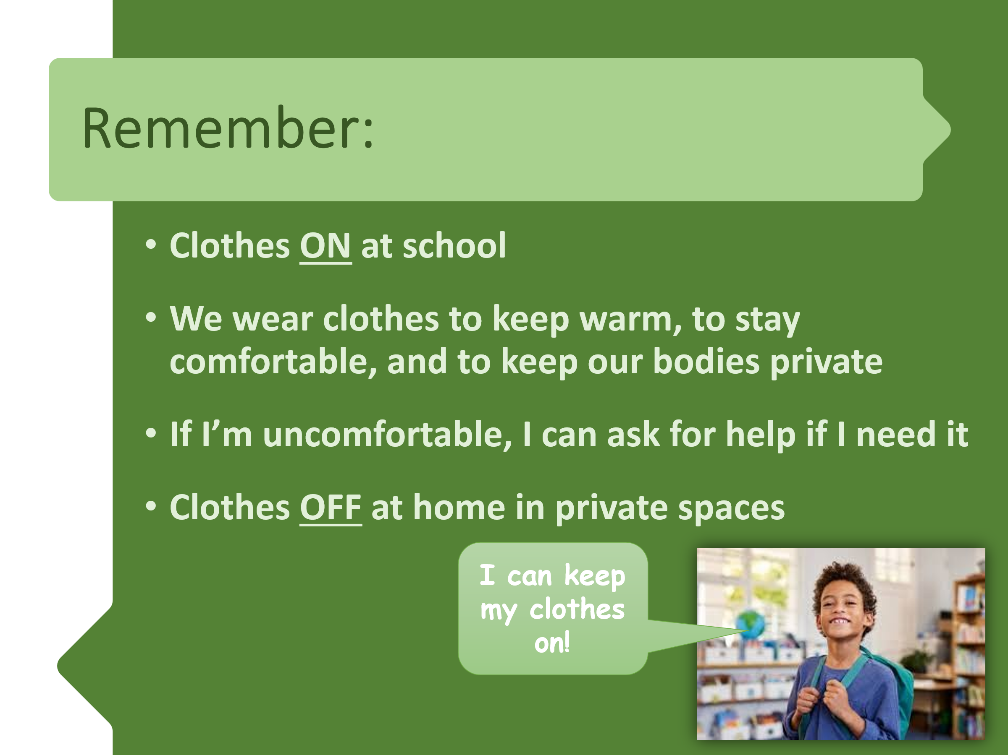
- So…what do you think?

- Get your magnet!

