This week I might try:

To Keep My Clothes on at School

I’ll try to remember that I need to keep my clothes on at school.
I can keep track of what I’m learning on the chart below:

I can: | Day  1 | Day  2 | Day  3 | Day  4 | Day  5
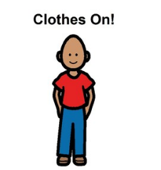
- Remember that clothes need to stay on at school

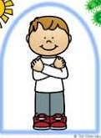
- Wear clothes to stay warm, comfortable, and to keep my body private

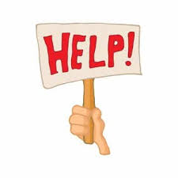
- If my clothes are uncomfortable, I can ask for help

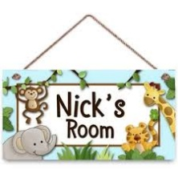
- I can take my clothes off at home in my bedroom or the bathroom



