
Social Skills –Teacher Note

Your student just completed a social skills lesson. The topic was:
I Can Solve Problems. Your knowledge of this lesson may help you to help your student generalize the skills to other environments.

What he/she learned:

- A problem is something that happens and makes you feel confused, upset, or stuck

- Everyone has problems – even adults!

- There are different kinds of problems – little and big

- Learning how to solve problems is important because it helps us feel more confident and supports our interactions with others

- 4 Tips for Solving Problems

- Identify the problem
- Think about possible solutions
- Pick one to try
- Try your solution

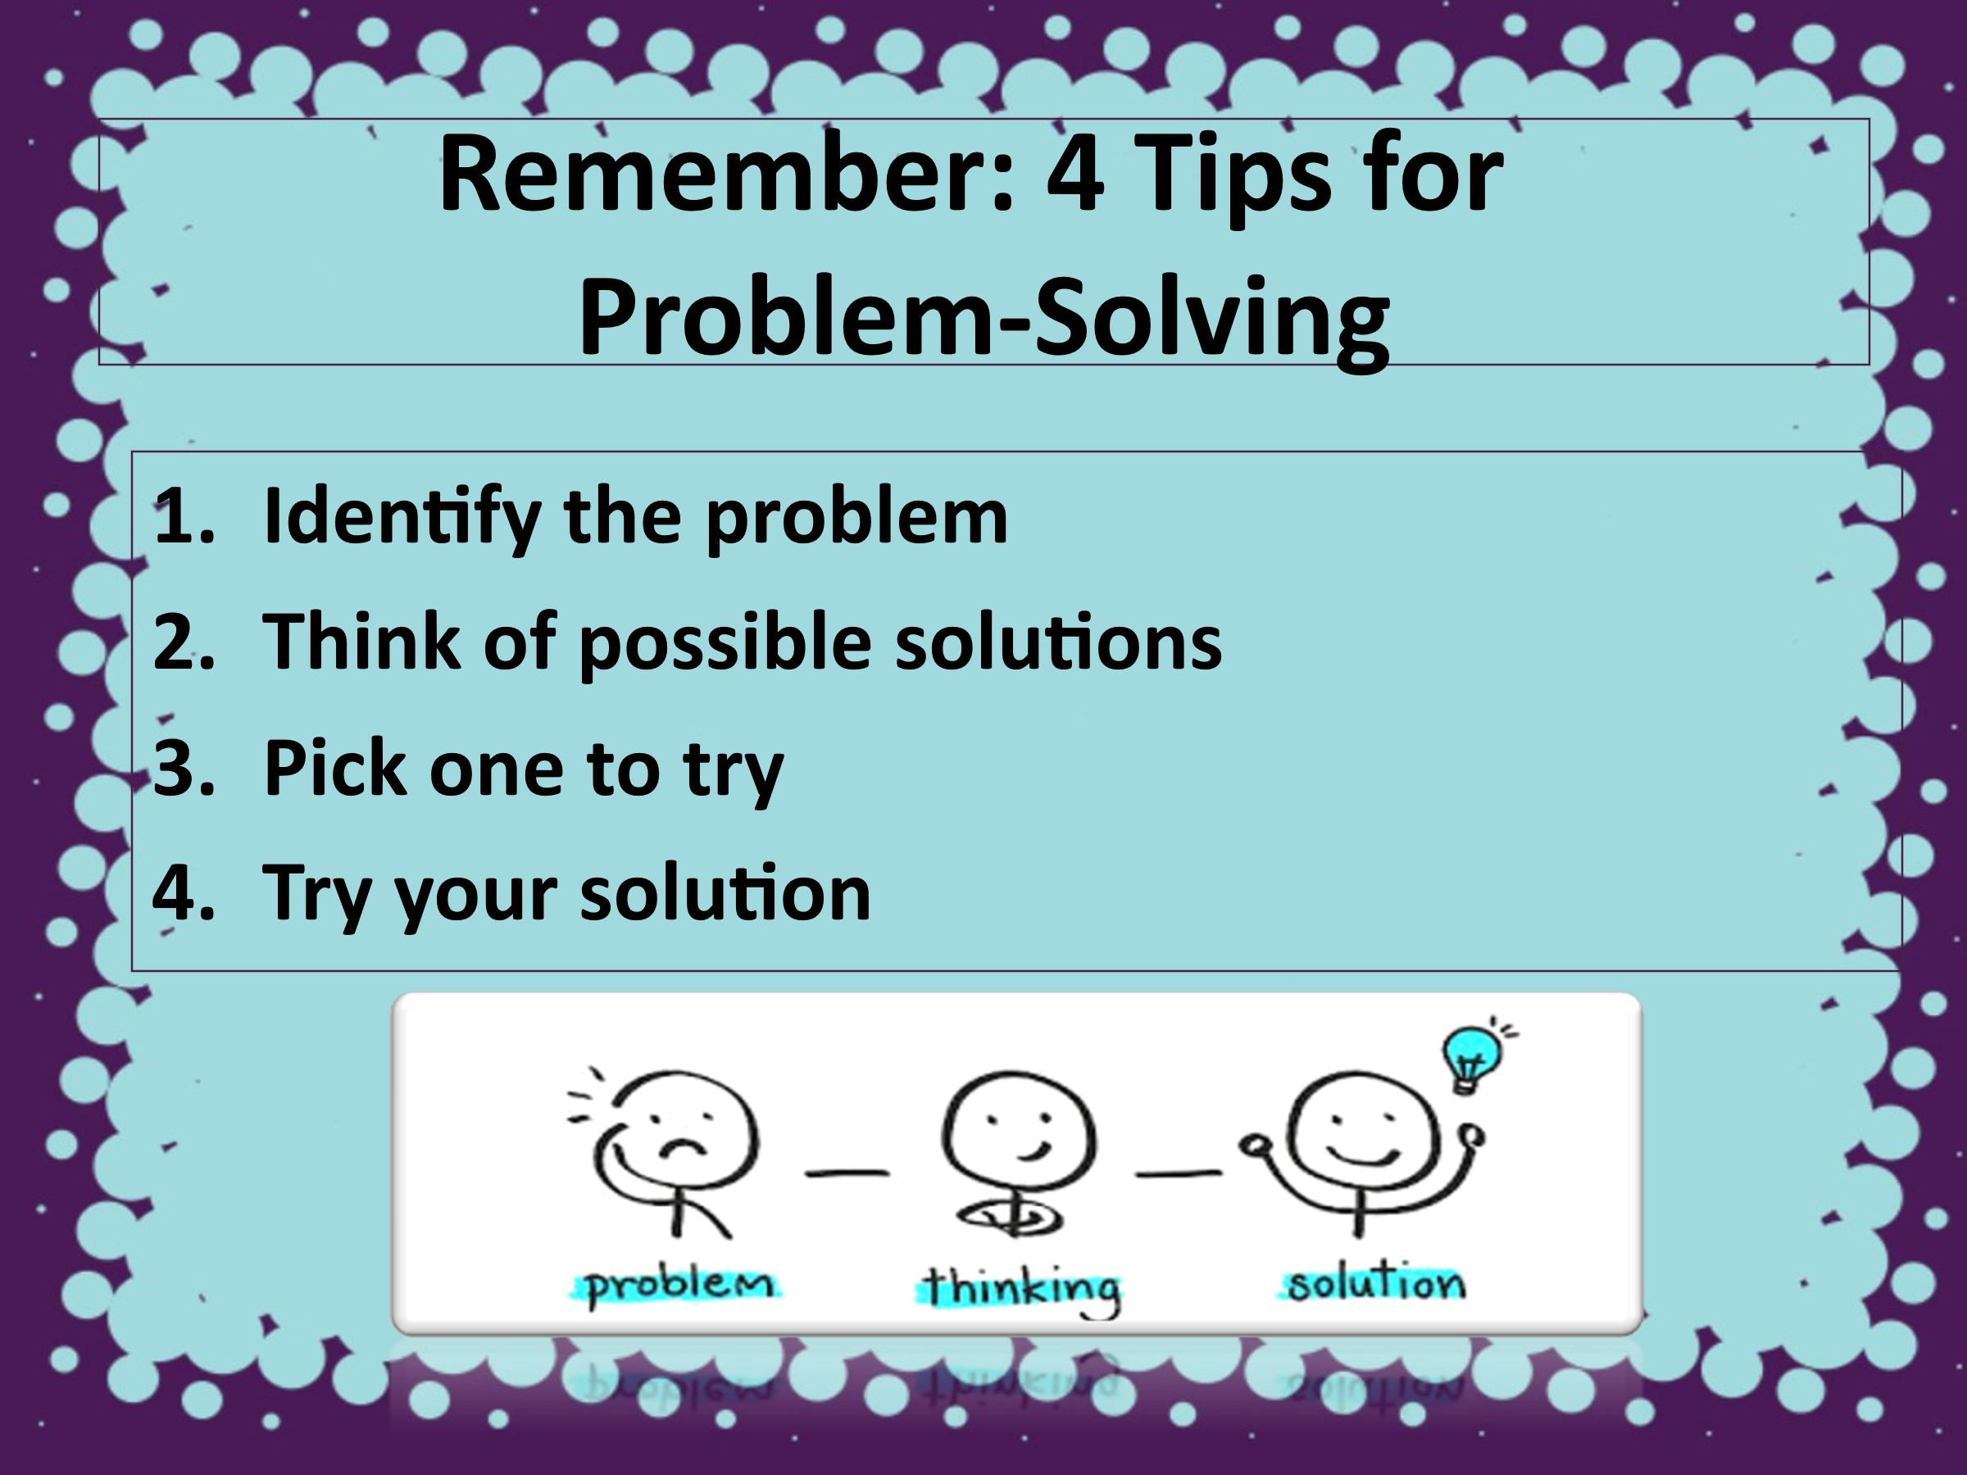
- So what do YOU think? discussion question

Your student received a Lesson Summary magnet:

If you have a moment, email _____________________________ with any information that might help your student for the next lesson on ________________________. THANK YOU!!

