What’s Happening Today?

Let’s Talk About How to Solve Problems

- Let’s define “problem”

- Why is learning how to solve problems important?

- There are different kinds of problems: little and big

- 4 Tips for Problem-Solving

- Identify the problem
- Think of possible solutions
- Pick one to try
- Try your solution

- So…what do you think?
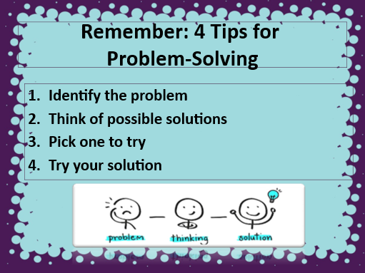
- Get your magnet!

