This week I might try:

To Use My Problem-Solving Skills

I’ll try to remember that there are things I can do to handle problems.
I can keep track of what I’m learning on the chart below:

I can: | Day  1 | Day  2 | Day  3 | Day  4 | Day  5

- Identify the problem


- Think of possible solutions

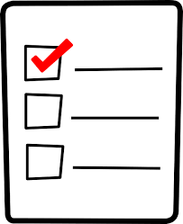
- Pick one to try

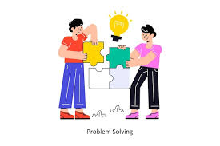
- Try my solution



