What’s Happening Today?

Let’s Talk About How to Accept Change

- Let’s define “change”

- There are BIG changes and LITTLE changes in life

- Changes can be planned or happen unexpectedly

- It’s okay to have different feelings about changes

- It’s important to learn to accept change because it’s part of life

- 6 Tips for Accepting Change:

- Ask questions
- Talk about your feelings
- Practice your calming strategies
- Make a plan
- Focus on the positive
- Take your time
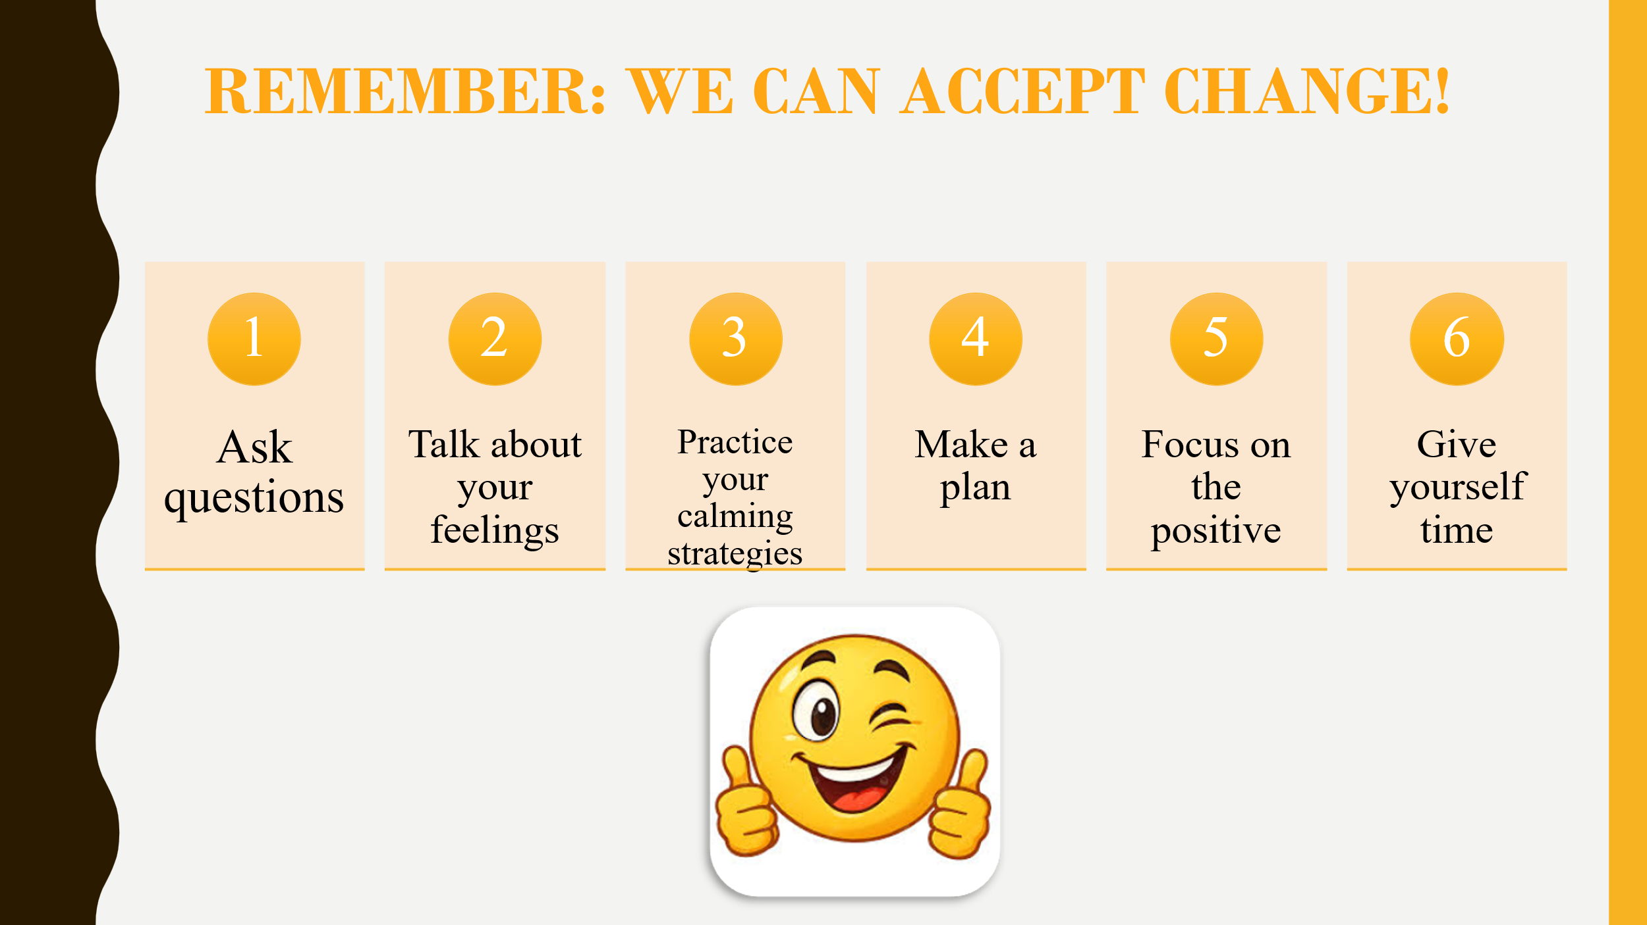
- So…what do you think?

- Get your magnet!

