This week I might try:

To Accept Change

I’ll try to remember that there are things I can do when there is a change.
I can keep track of what I’m learning on the chart below:

I can: | Day  1 | Day  2 | Day  3 | Day  4 | Day  5

- Ask questions


- Talk about my feelings


- Use my calming strategies

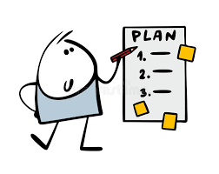
- Make a plan


- Focus on the positive


- Give myself time



