
Social Skills – Parent Note

Your child just completed a social skills lesson. The topic was:
I Know How to Act in a Restaurant. Your knowledge of this lesson may help you to help your child generalize the skills to other environments.

What he/she learned:

- Eating in a restaurant can be fun

- Things to expect: different sensory experiences; having to wait for a table; choosing from the menu; giving order to server; having to wait for food; table manners while eating; talking quietly; pay the bill before leaving

- There are strategies that can help when eating in a restaurant

- Take time to get used to the sensory input
- Stay busy if we have to wait for a table
- Stay in my seat at the table
- Pick something I like from the menu
- Stay busy while waiting for the food
- Use my best manners while eating
- Talk using an indoor voice
- Pay the bill before leaving

- So what do YOU think? discussion question
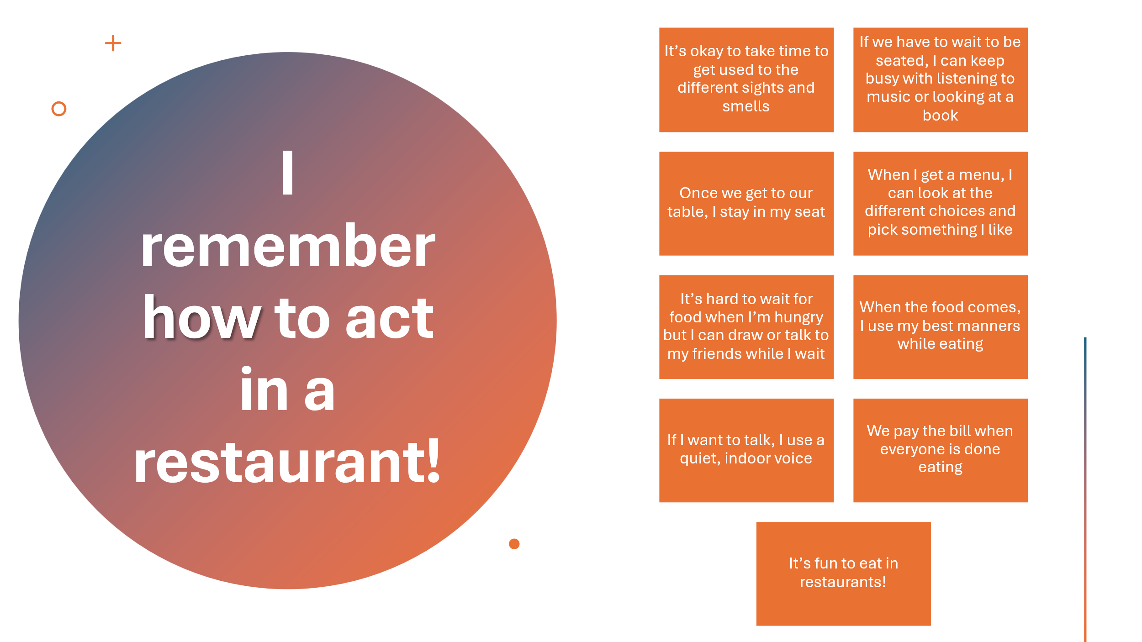

Your child received a Lesson Summary magnet:

If you have a moment, email _____________________________ with any information that might help your child for the next lesson on ________________________. THANK YOU!!

