What’s Happening Today?

Let’s Talk About How to Act in a Restaurant

- Eating in a restaurant can be fun

- There are different sensory experiences in a restaurant

- Once seated, stay at the table

- Check out the menu

- Give your order to the server

- Stay busy while waiting for the food

- Use good table manners while eating

- Use indoor voice when talking

- Pay the bill before leaving

- So…what do you think?
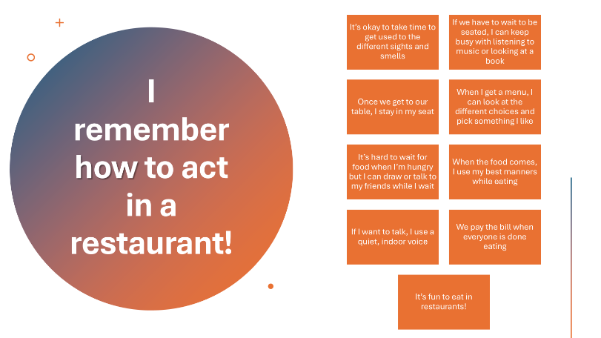
- Get your magnet!

