This week I might try:

To Act the Right Way in a Restaurant

I’ll try to remember that there are things I can do when eating in a restaurant.
I can keep track of what I’m learning on the chart below:

I can act the right way in a restaurant if I remember to: | Day  1 | Day  2 | Day  3 | Day  4 | Day  5
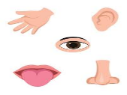
- Take time to get used to the sights, sounds, and smells


- Keep busy while waiting for a table


- Stay in my seat at the table

- Pick something I like from the menu
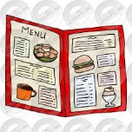

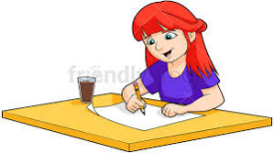
- Keep busy while I’m waiting for my food


- Use good table manners while eating

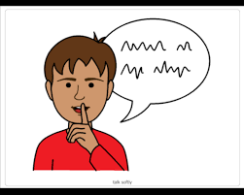
- Talk quietly in the restaurant

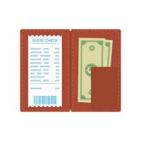
- Pay the bill before leaving

