
Social Skills –Teacher Note

Your student just completed a social skills lesson. The topic was:
My Actions Have Consequences. Your knowledge of this lesson may help you to help your student generalize the skills to other environments.

What he/she learned:

- The things we say and do can affect ourselves and others. A “consequence” is what happens after we say or do something.

- There are good and not so good consequences that can be the result of our actions.

- 5 things to remember that might help ensure more positive outcomes:

- Stop
- Think about what might happen
- Ask for help if unsure
- Think about how my actions may make others feel
- Remember that my actions have consequences

- So what do YOU think? discussion question

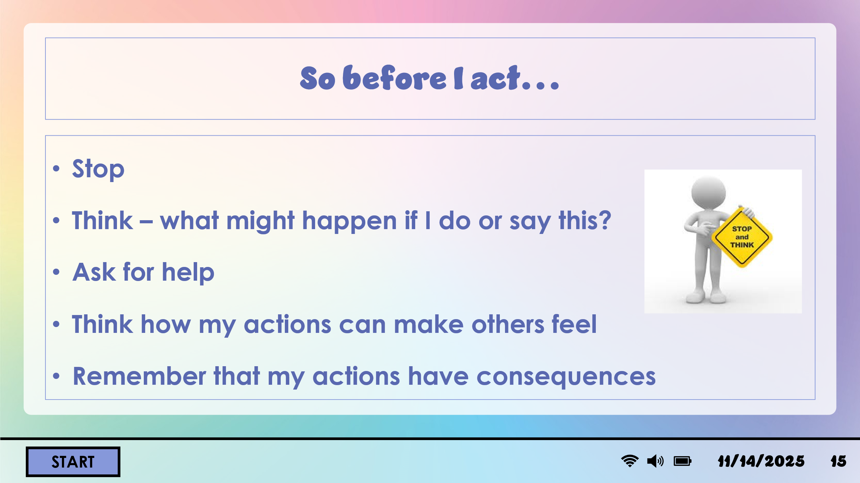
Your student received a Lesson Summary magnet:

If you have a moment, email _____________________________ with any information that might help your student for the next lesson on ________________________. THANK YOU!!

