This week I might try:
To remember that my actions have consequences

I’ll try to remember the 5 things that will help me take control of my actions.

I can keep track of what I’m learning on the chart below:

I’m in control of my actions. | Day  1 | Day  2 | Day  3 | Day  4 | Day  5
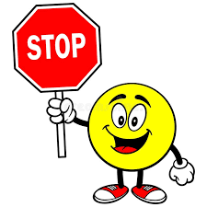
- Stop

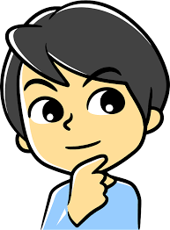
- Think what might happen

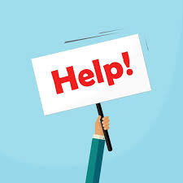
- Ask for help

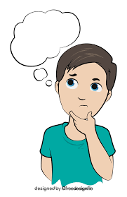
- Think how my actions can make others feel
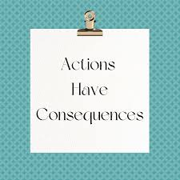
- Remember that my actions have consequences



