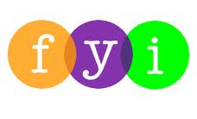
Social Skills –Teacher Note

Your student just completed a social skills lesson. The topic was:
I Can Handle Lockdown Drills. Your knowledge of this lesson may help you to help your student generalize the skills to other environments.

What he/she learned:

- Why schools have Lockdown Drills – to have a plan to keep everyone safe in dangerous situations

- There are strategies that can help during a Lockdown Drill
- Remember PAL – Pause, Adult, Listen
- Hide where trusted adult tells you
- Stay quiet
- Your teacher will close down the room – don’t open the door!
- Wait for the signal
- Talk about it

- So what do YOU think? discussion question

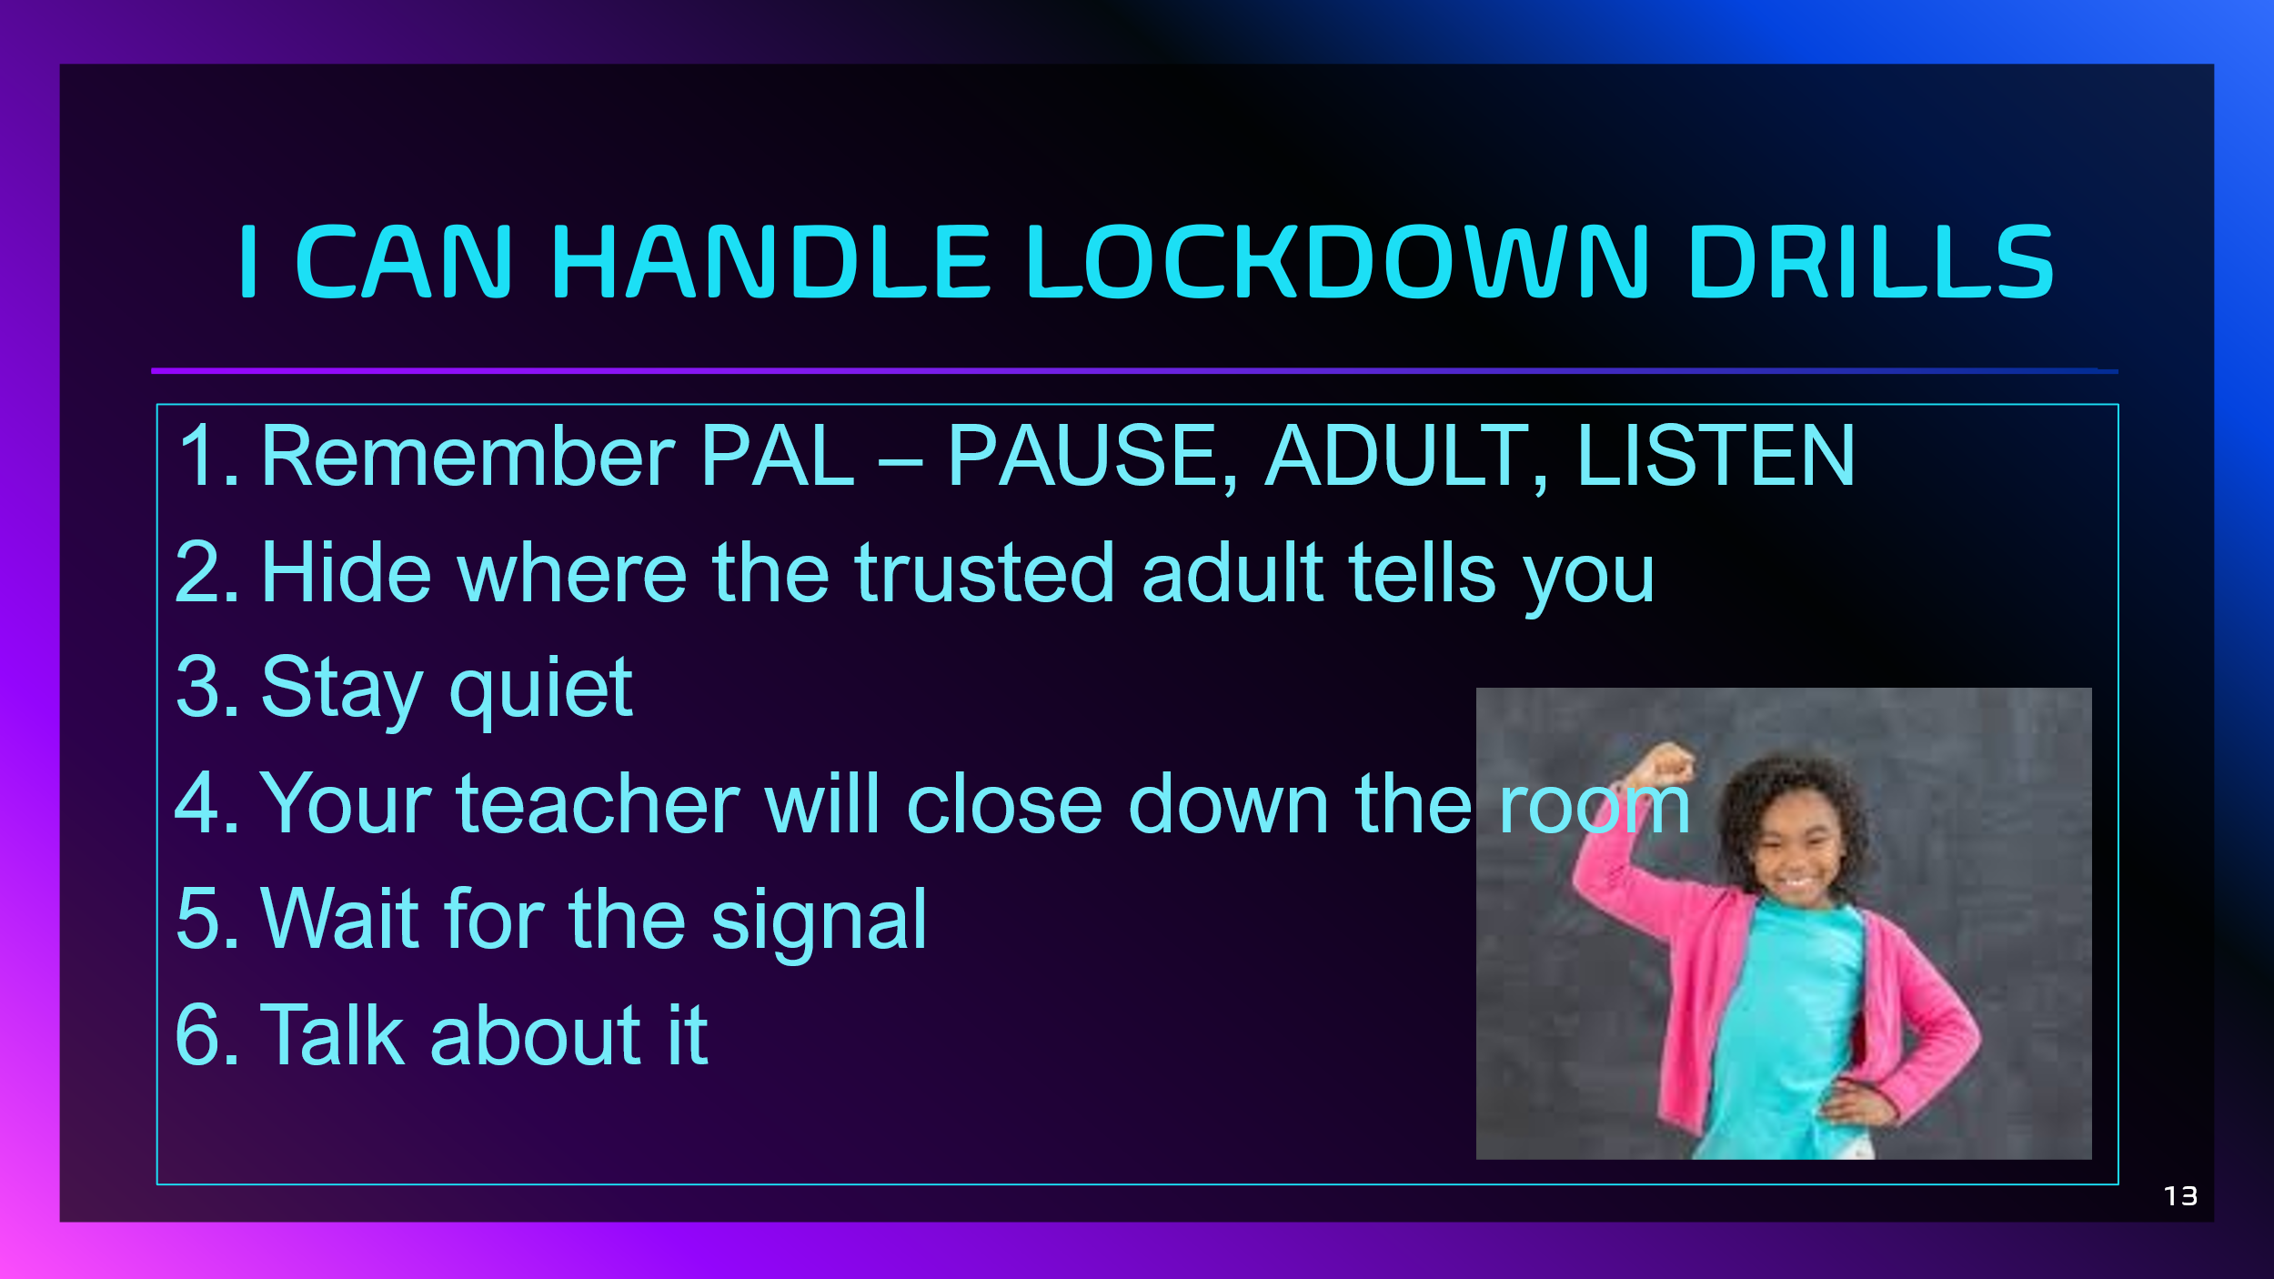
Your student received a Lesson Summary magnet:

If you have a moment, email _____________________________ with any information that might help your student for the next lesson on ________________________. THANK YOU!!

