This week I might try:

To Handle Lockdown Drills

I’ll try to remember that there are things I can do to keep safe during Lockdown Drills.

I can keep track of what I’m learning on the chart below:

I can keep safe during Lockdown Drills if I remember: | Day  1 | Day  2 | Day  3 | Day  4 | Day  5
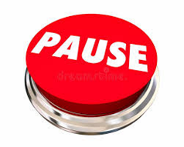
- PAL – Pause, Adult, Listen

- Hide where trusted adult tells me to
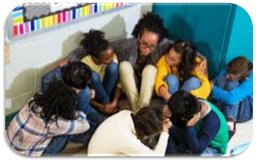

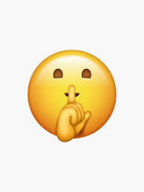
- Stay quiet

- My teacher will close down the room
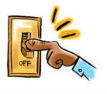
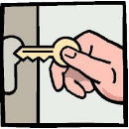
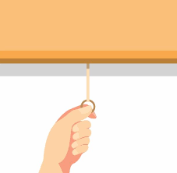

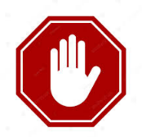
- Wait for the signal

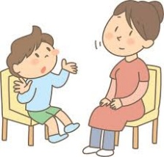
- Talk about it

