Social Skills –Parent Note

Your child just completed a social skills lesson. The topic was:
I Can Choose the Right Clothes. Your knowledge of this lesson may help you to help your child generalize the skills to other environments.

What he/she learned:

- Choosing the right clothing can be tricky
- Different occasions/situations call for different kinds of clothing

- There are 8 Tips for Choosing the Right Clothes

- Organize your closet and drawers
- Think about where you’re going
- Check the weather
- Check the fit
- Plan the night before
- Choose comfort
- Pick the right shoes
- Ask family and friends

- So what do YOU think? discussion question

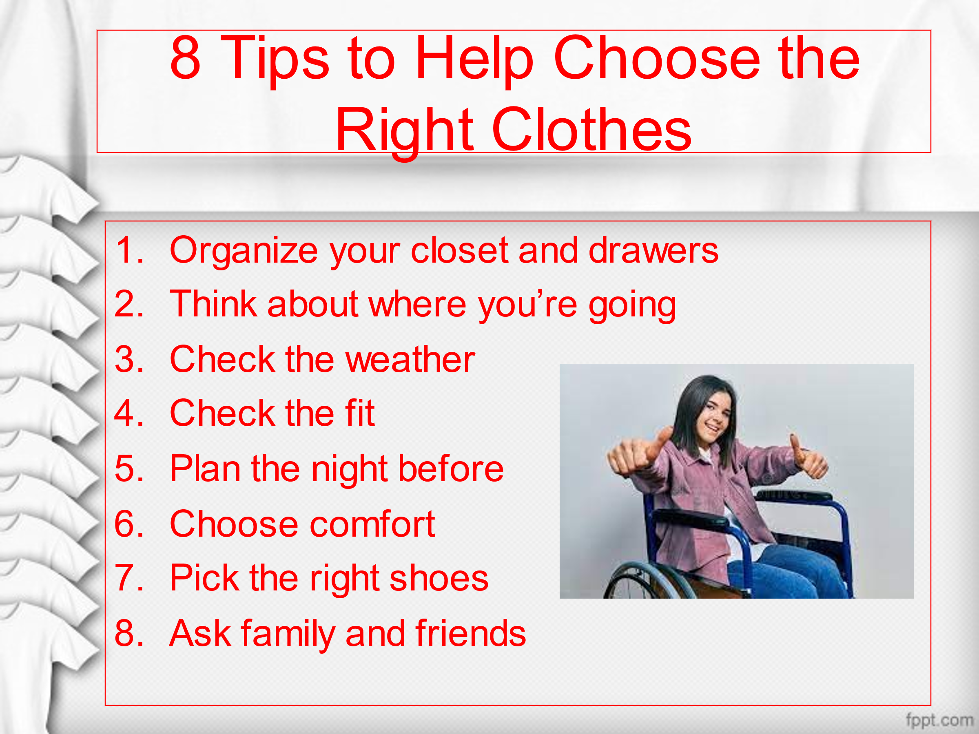
Your child received a Lesson Summary magnet:

If you have a moment, email _____________________________ with any information that might help your child for the next lesson on ________________________. THANK YOU!!

