This week I might try:
To Choose the Right Clothes

I’ll try to remember that there are 8 Tips for choosing the right clothes

I can keep track of what I’m learning on the chart below:

I Can Choose the Right Clothes | Day  1 | Day  2 | Day  3 | Day  4 | Day  5
- Organize my closet and drawers
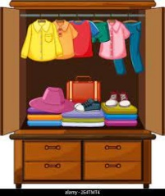

- Think about where I’m going

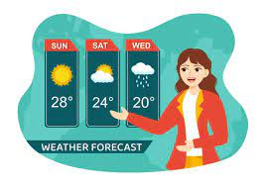
- Check the weather

- Check the fit
- Plan the night before

- Choose comfort
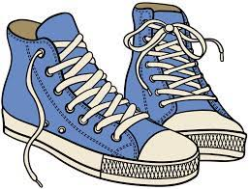
- Pick the right shoes
- Ask family and friends

