ACTIVITY: I CAN CHOOSE THE RIGHT CLOTHES!

MATERIALS:
- Magazines
- Internet access (google images)
- White construction paper
- Glue sticks
- Markers
- File folders

PROCEDURE:
- Review the tips learned in “I Can Choose the Right Clothes” PowerPoint
- Explain that students can choose an occasion (wedding, school, dance, party, funeral, date, hanging out with friends)
- Have students label paper with the occasion
- Let students look through magazines or on internet to select appropriate clothing for their occasion. Cut out or print pictures and glue to paper.
- When completed, let students choose another occasion and repeat the process
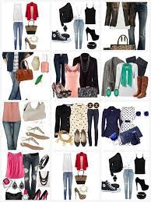
- Have students assemble their occasions into a folder for future reference

