Social Skills –Teacher Note

Your student just completed a social skills lesson. The topic was:
Let’s Talk About Talking. Your knowledge of this lesson may help you to help your student generalize the skills to other environments.

What he/she learned:

- Talking with another person is having a “conversation”.
- It’s important to use the right tone and volume when speaking with another person. If we’re too loud, people may not want to speak with us. If we’re too soft, people may not understand what we’re saying.
- Students learned 5 Tips for Talking
- Check your breathing
- Vary your vocal pitch
- Check your speed
- Check your volume
- Make sure to let the other person talk too!

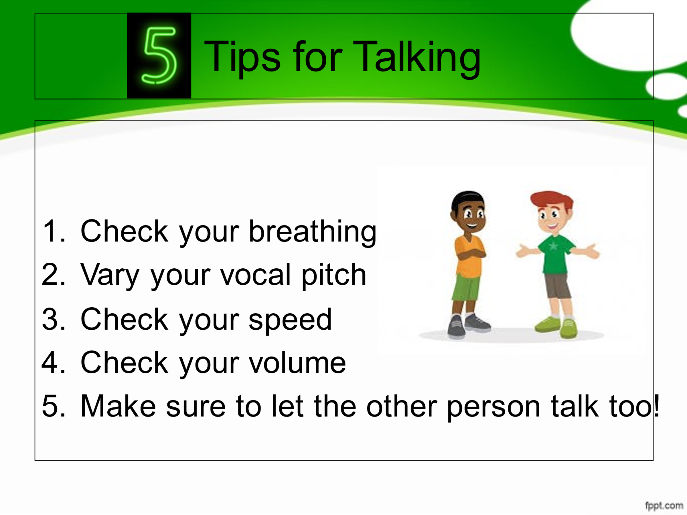
Your student received a Lesson Summary magnet:

If you have a moment, email _____________________________ with any information that might help your student for the next lesson on ________________________. THANK YOU!!

