When I’m talking with someone…

I’ll try to remember the following tips so that I can have a good conversation with the other person.

I can keep track of what I’m learning on the chart below:

I can have a good conversation with someone if I… | Monday | Tuesday | Wed. | Thurs. | Friday
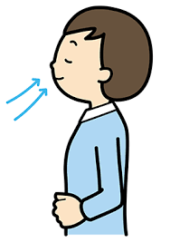
1. Check my breathing

2. Vary my vocal pitch

3. Check my speed

4. Check my volume

5. Make sure to let the other person talk too!
