Social Skills –Parent Note

Your child just completed a social skills lesson. The topic was:
I Can Handle Fire Drills. Your knowledge of this lesson may help you to help your child generalize the skills to other environments.

What he/she learned:

- Our school has fire drills so that we can practice how to safely leave the building in case of a fire.
- Students talked about why the fire drill needs to be so loud (so that everyone in the building can hear it no matter where they are) and that some people might need to cover their ears to muffle the sound. That’s okay as long as you can still hear the teacher!
- Students learned 6 Fire Drill Safety Rules
- Listen for directions
- Line up quickly and quietly
- Walk
- Go to your assigned place outside
- Stay with your class
- Wait for the signal

Your child received a Lesson Summary magnet:
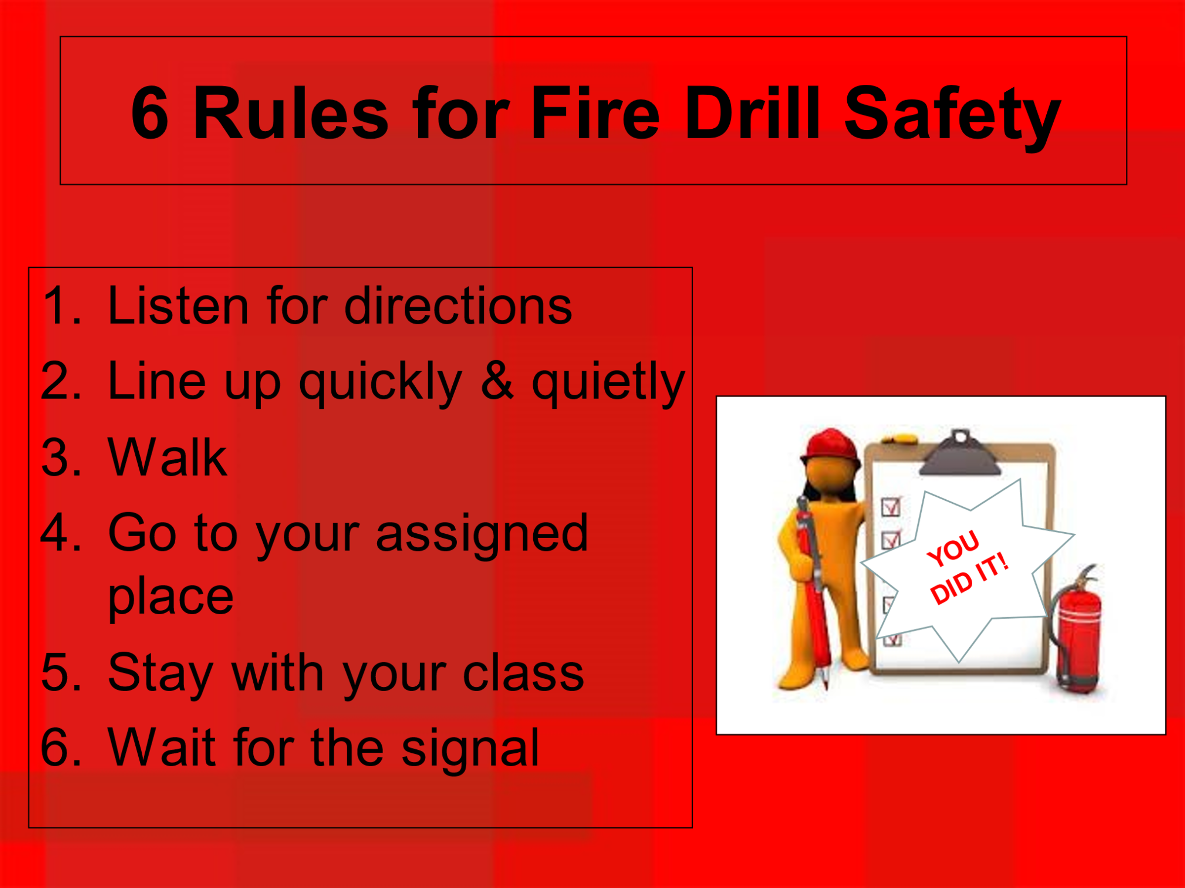

If you have a moment, email _____________________________ with any information that might help your child for the next lesson on ________________________. THANK YOU!!

