For the next Fire Drill at school…

I’ll try to remember the following rules to keep safe during the monthly Fire Drills at school.

I can keep track of what I’m learning on the chart below:

I can keep safe during fire drills if I… | Month  1 | Month  2 | Month  3 | Month  4 | Month  5
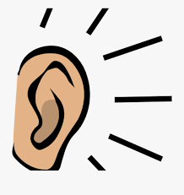
- Listen for directions

- Line up quickly and quietly

- Walk

- Go to my assigned place outside
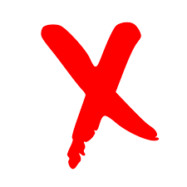

- Stay with my class

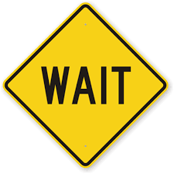
- Wait for the signal

