Social Skills –Teacher Note

Your student just completed a social skills lesson. The topic was:
I Can Give Compliments. Your knowledge of this lesson may help you to help your student generalize the skills to other environments.

What he/she learned:

- A “compliment” is to politely praise or congratulate someone for something
- Students talked about how giving compliments can make someone feel good but also make you feel good too!
- Students discussed who to give compliments to and what to compliment
- Students learned 6 Guidelines for Giving Compliments
- Be warm and sincere
- Be specific
- Be generous – but not too much
- Smile and make eye contact
- Check your tone of voice
- Keep compliments polite and respectful

Your student received a Lesson Summary magnet:
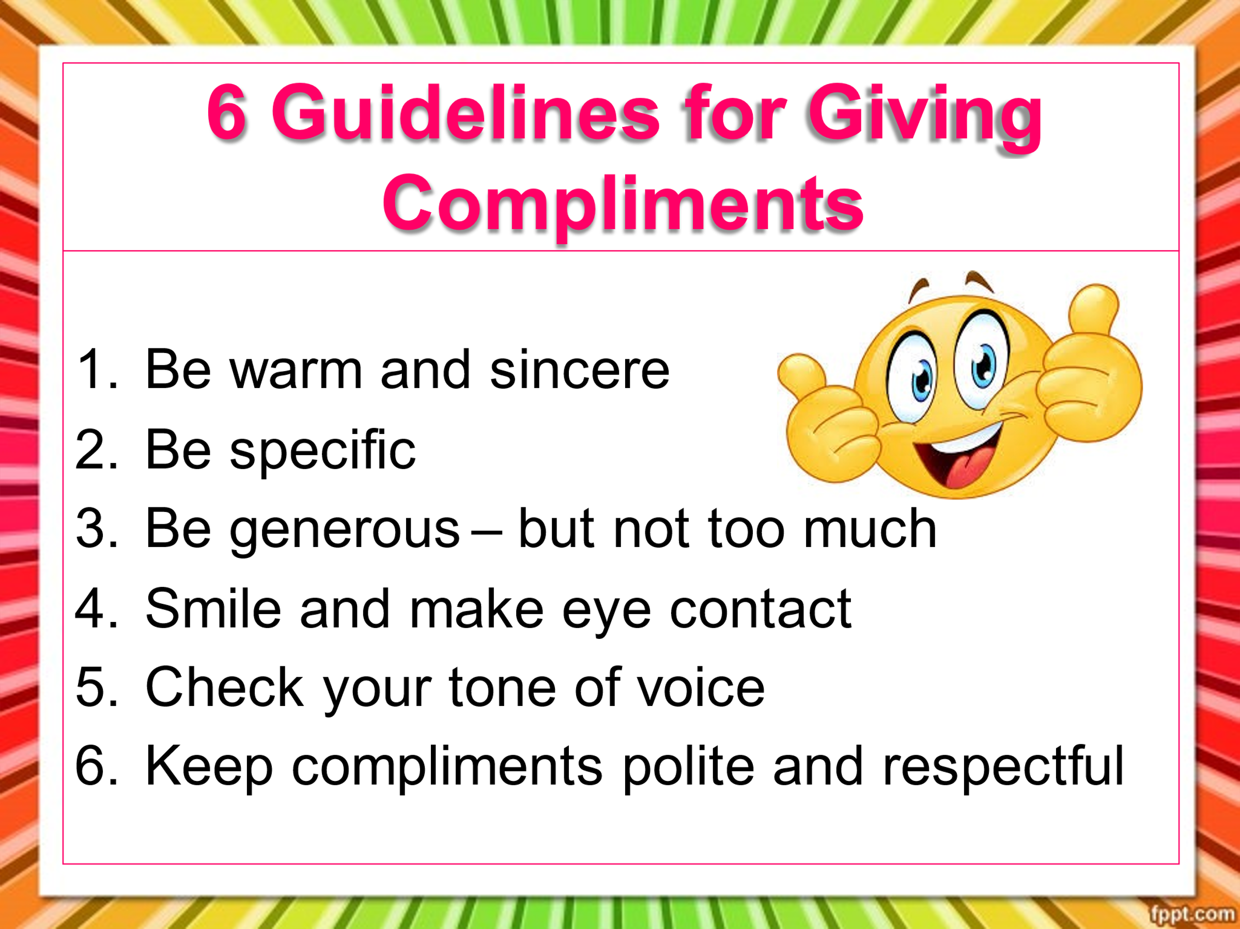

If you have a moment, email _____________________________ with any information that might help your student for the next lesson on ________________________. THANK YOU!!

