This week I might try:

To give compliments

I’ll try to remember that giving compliments can make other people feel good – and make me feel good too!

I can keep track of what I’m learning on the chart below:

I can remember the guidelines for giving compliments: | Day  1 | Day  2 | Day  3 | Day  4 | Day  5
1. Be warm and sincere

Your science fair project is awesome! How did you make that volcano?
That’s a science
2. Be specific

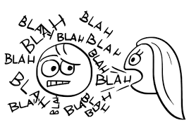
3. Be generous – but not too much

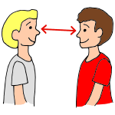
4. Smile and make eye contact

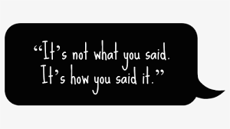
5. Check your tone of voice

6.Keep compliments polite and respectful

