ACTIVITY: Friendship Suns
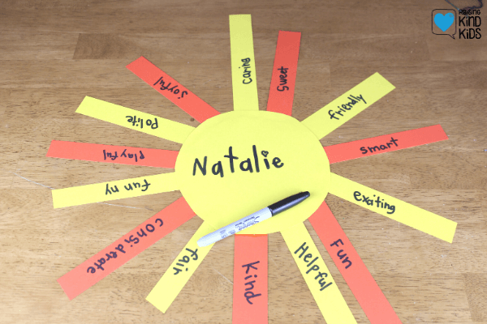

MATERIALS NEEDED:
- orange and yellow construction paper
- scissors
- markers
- glue sticks
DIRECTIONS:
- explain that students can make a Friendship Sun for a classmate or family member
- help them cut out strips of orange and yellow construction paper for the rays, and a large circle for the sun [pre-cut the strips and circles to save time or for students who have fine motor difficulty]
- tell students to write a different compliment about their classmate or family member on each sun ray [students can write down compliments on a list beforehand OR dictate to an adult for them to write]
- help them glue the rays to the center circle
- encourage them to give their friendship sun to their classmate or family member with a sincere smile!

