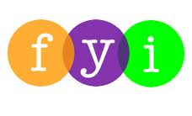
Social Skills –Parent Note

Your child just completed a social skills lesson. The topic was:
I Can Learn Self-Advocacy. Your knowledge of this lesson may help you to help your child generalize the skills to other environments.

What he/she learned:

- “Self-Advocacy” means speaking up for yourself so that you can get what you need
- Students talked about the benefits of speaking up for yourself in the right way and what happens if you use inappropriate means (i.e. shutting down = needs not met because adults can’t understand what you want)
- Students learned 3 Parts of Self-Advocacy
- Know yourself
- Know your needs
- Know how to get what you need

Your child received a Lesson Summary magnet:

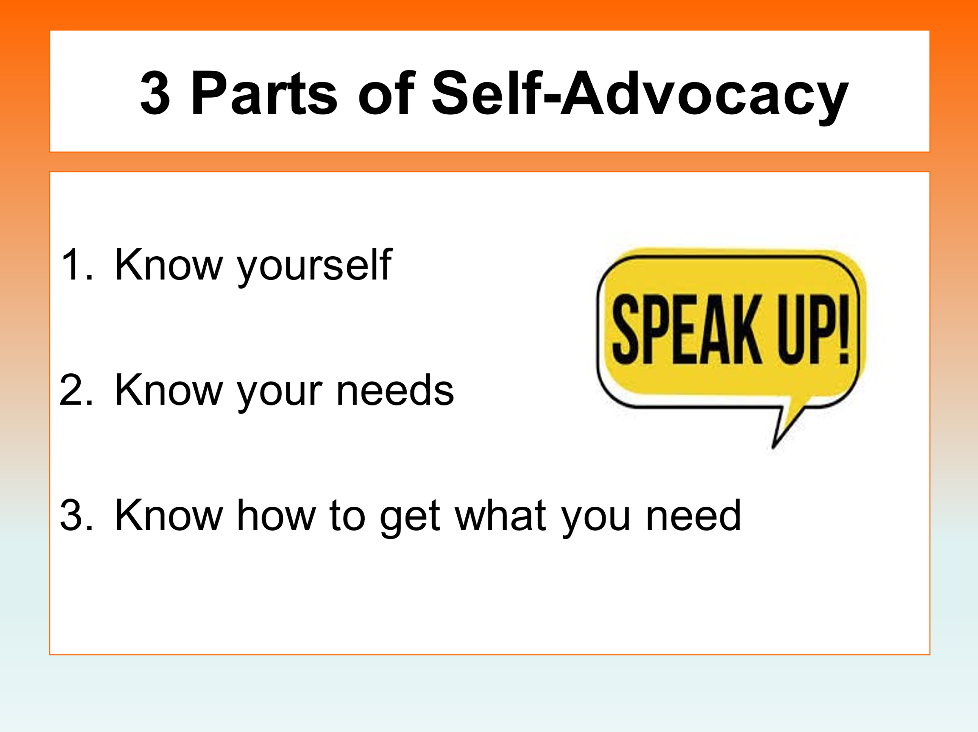

If you have a moment, email _____________________________ with any information that might help your child for the next lesson on ________________________. THANK YOU!!

