Social Skills –Parent Note

Your child just completed a social skills lesson. The topic was:
I Can Have a Growth Mindset. Your knowledge of this lesson may help you to help your child generalize the skills to other environments.

What he/she learned:

- Everyone feels frustrated or discouraged sometimes. We can stay frustrated or discouraged OR we can have a GROWTH MINDSET
- A Growth Mindset is believing our brains can grow and we can learn many new things
- Fixed Mindset vs. Growth Mindset
- We can challenge our brains to help them grow stronger
- We can turn negative thoughts into positive ones
- We can develop a CAN DO attitude!
- 6 Steps to Develop a Growth Mindset
- Pay attention to self-talk
- Be open to learning
- Recognize your strengths
- Welcome challenges and embrace feedback
- Track your progress
- Believe in yourself!

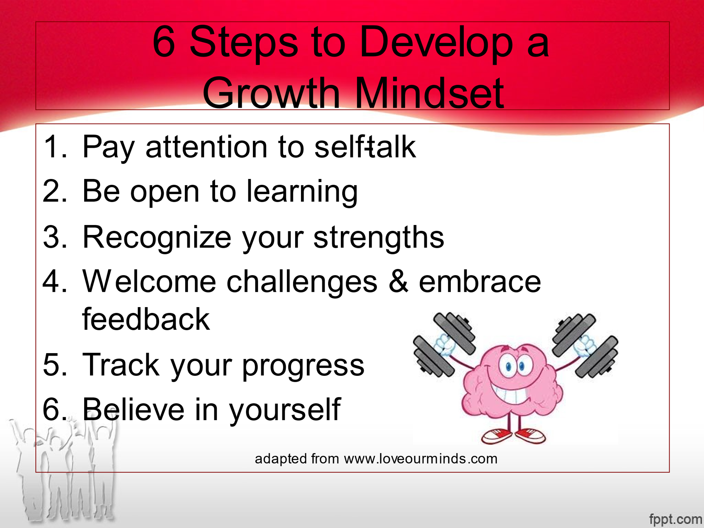
Your child received a Lesson Summary magnet:

If you have a moment, email _____________________________ with any information that might help your child for the next lesson on ________________________. THANK YOU!!

