Social Skills – Teacher Note

Your student just completed a social skills lesson. The topic was:
I Can Get Organized. Your knowledge of this lesson may help you to help your student generalize the skills to other environments.

What he/she learned:

- “Getting Organized” means putting different parts of something in a certain order so that they can be found or used easily
- Students looked at different pictures to select the organized locker, desk, bedroom
- Students discussed how it feels when you can’t find something you’re looking for because of disorganization
- 7 Ways to Get Organized
- Get a pencil box or pouch
- Keep your locker neat
- Keep your desk clean
- Manage your backpack
- Use a planner or checklist
- Color-code your binders or notebooks
- Pick out your clothing the night before

Your student received a Lesson Summary magnet:

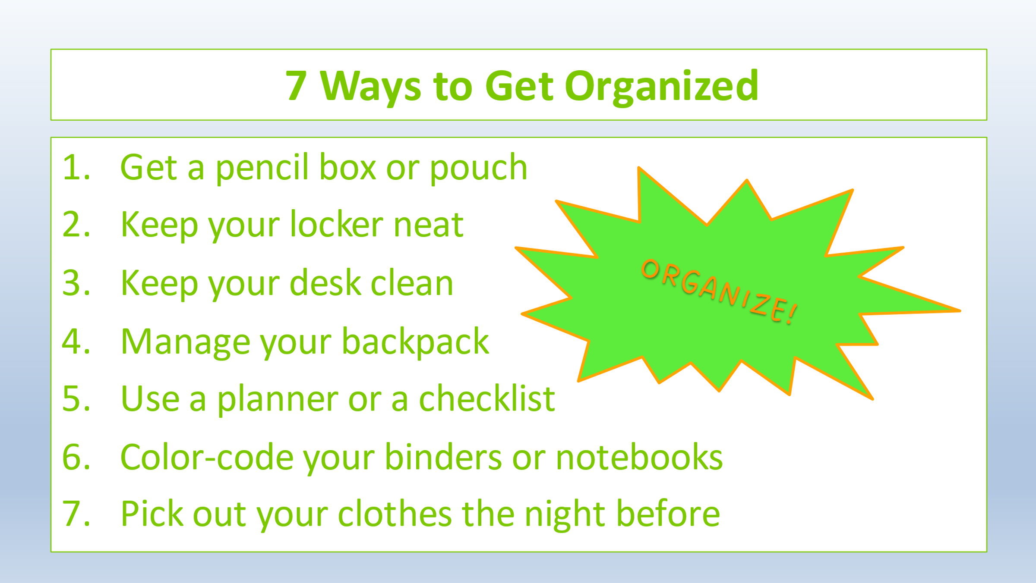

If you have a moment, email _____________________________ with any information that might help your student for the next lesson on ________________________. THANK YOU!!

