This week I might try:

To Get Organized

I’ll try to remember that there are things I can do to help me get organized. It’s important to be organized so that I don’t forget anything or get frustrated because I can’t find what I’m looking for.

I can keep track of what I’m learning on the chart below:

I can get organized if I: | Day  1 | Day  2 | Day  3 | Day  4 | Day  5
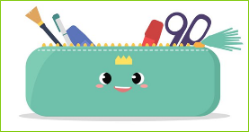
1. Get a pencil box or pouch

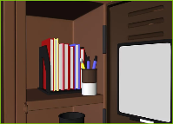
2. Keep my locker neat

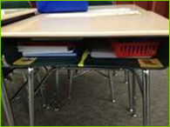
3. Keep my desk clean

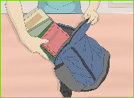
4. Manage my backpack

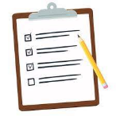
5. Use a planner or checklist

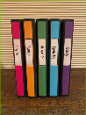
6. Color-code my binders or notebooks

7. Pick out my clothes the night before

